**Are you ready to be an AWS Cloud Practitioner!?**

This a compilation of notes from multiple resources and covers all important topics you need to know to crack the exam.

**SECTION 1: WHAT IS CLOUD COMPUTING**

**Traditional IT Systems**

Before we see what cloud computing is, we need to understand why it was needed in the first place. In a traditional IT system if we want to access a website, we as the client through a network access the server hosting the website (clients and severs have IP addresses so they can find each other). The server is the key player. It has a CPU to compute, Ram to store memory, more data storage space, database to store data in a structured way and routers, switches and DNS server to enable communication. Clearly, maintaining all the components of this system cannot be easy and this is where cloud comes in.

**What is Cloud Computing**

* It is the **on-demand** delivery of compute power, database storage, applications and other IT resources.
* **Pay-as-you-go-pricing**: you only pay for what you *use*.
* You can provision exactly the right type and size of computing resource you need.
* You access as many resources you need almost instantly.
* Simple way to access servers, storage, databases and a set of application services

**The Deployment Models of Cloud**

1. **Private cloud**: Cloud services used by a single organisation, not exposed to the public. Complete control, Security for sensitive applications and meets specific business needs.
2. **Public Cloud**: Cloud resources owned and operated by a third- party cloud service provider delivered over the Internet. Eg: AWS, Azure, Google Cloud
3. **Hybrid Cloud**: Keep some servers on premises and extend some capabilities to the Cloud. Control over sensitive assets in your private infrastructure. Flexibility and cost- effectiveness of the public cloud.

**Five Characteristics of Cloud Computing**

1. **On-demand self service**: You can provision what you need without external help.
2. **Broad network access**: Resources available over the network, and can be accessed by diverse client platforms. Therefore, the prices will slowly go down as the consumer base increases.
3. **Multi-tenancy and resource pooling**: Multiple customers can share the same infrastructure and applications with security and privacy. Multiple customers are serviced from the same physical resources.
4. **Rapid elasticity and scalability**: Automatically and quickly acquire and dispose resources when needed. Quickly and easily scale based on demand.
5. **Measured service**: Usage is measured, users pay correctly for what they have used

**Six Advantages of Cloud Computing**

1. Trade capital expense (**CAPEX**) for operational expense (**OPEX**)  
   • Pay On-Demand: don’t own hardware  
   • Reduced Total Cost of Ownership (TCO) & Operational Expense (OPEX)
2. Benefit from **massive economies of scale**  
   • Prices are reduced as AWS is more efficient due to large scale
3. **Stop guessing capacity**  
   • Scale based on actual measured usage
4. Increase **speed and agility**
5. Stop spending money running and maintaining data centres
6. Go **global in minutes**: leverage the AWS global infrastructure

**Problems solved by the Cloud**

* **Flexibility**: change resource types when needed
* **Cost-Effectiveness**: pay as you go, for what you use
* **Scalability**: accommodate larger loads by making hardware stronger or adding additional nodes
* **Elasticity**: ability to scale out and scale-in when needed
* **High-availability and fault-tolerance**: build across data centers
* **Agility**: rapidly develop, test and launch software applications

**Types of Cloud Computing**

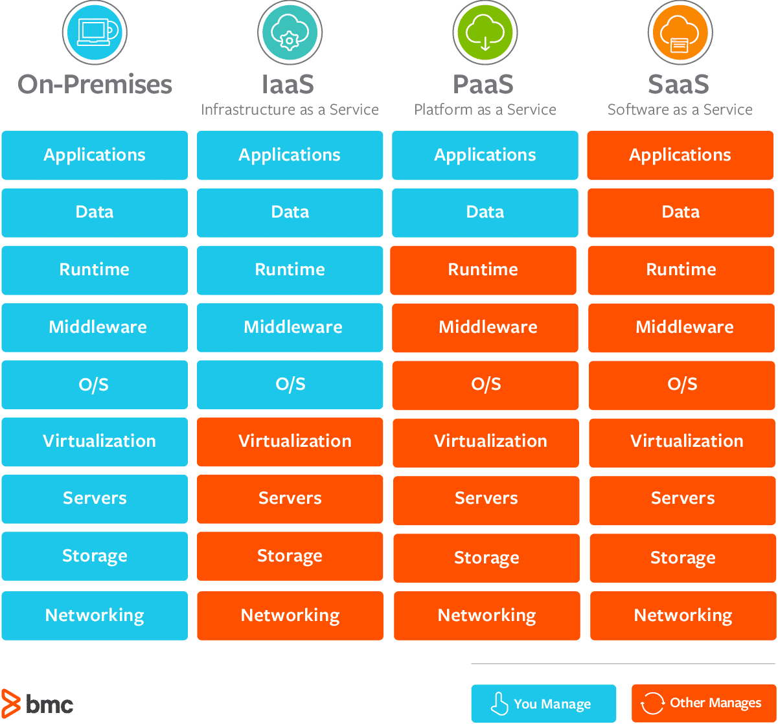

**Quick overview of pay-as-you-go-pricing in AWS:**

AWS has 3 pricing fundamentals, following the pay-as-you-go pricing model

* Compute:  
  • Pay for compute time
* Storage:  
  • Pay for data stored in the Cloud
* Data transfer OUT of the Cloud

• Data transfer IN is free

**AWS Infrastructure**

**AWS Regions:**

* AWS has Regions all around the world
* Names can be us-east-1, eu-west-3…
* A region is a cluster of data centers
* Most AWS services are region-scoped

**How to choose an AWS Region?**

**Compliance** with data governance and legal requirements: data never leaves a region without your explicit permission.  
**Proximity** to customers: reduced latency.  
**Available services** within a Region: new services  
**Pricing**: pricing varies region to region and is transparent in the service pricing page

**AWS Availability Zones**

* Each region has many availability zones (usually 3, min is 2, max is 6).
* Each availability zone (AZ) is **one or more discrete data centers** with redundant power, networking, and connectivity.
* They’re separate from each other, so that they’re isolated from disasters.
* They’re connected **with high bandwidth, ultra-low latency networking.**

**AWS Points of Presence (Edge Locations)**

* Amazon has 216 Points of Presence (205 Edge Locations & 11 Regional Caches) in 84 cities across 42 countries
* Content is delivered to end users with lower latency

**AWS has Global Services:**  
• Identity and Access Management (IAM)  
• Route 53 (DNS service)  
• CloudFront (Content Delivery Network)  
• WAF (Web Application Firewall)

**Most AWS services are Region-scoped**:  
• Amazon EC2 (Infrastructure as a Service)  
• Elastic Beanstalk (Platform as a Service)  
• Lambda (Function as a Service)  
• Rekognition (Software as a Service)

**Shared Responsibility Model diagram**

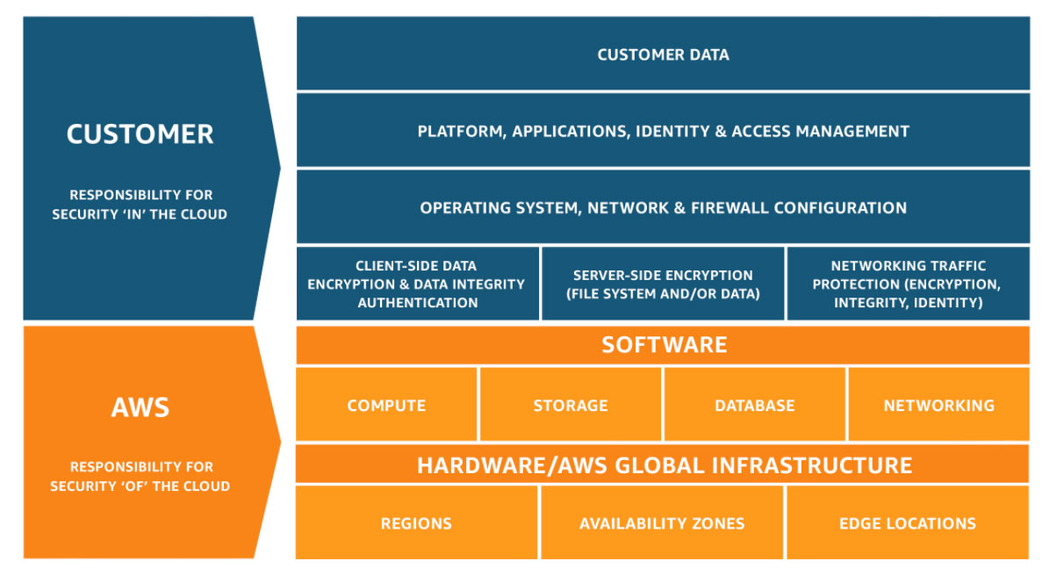

CUSTOMER = RESPONSIBILITY FOR THE SECURITY **IN** THE CLOUD  
AWS = RESPONSIBILITY FOR THE SECURITY **OF** THE CLOUD

**SECTION 2: IAM – IDENTITY AND ACCESS MANAGEMENT**

It’s a global service. When we create an account, we automatically have a root account which shouldn’t be used or shared.

**Users, Groups and Policies**

* Root account - shouldn’t be used or shared
* Create users (group them if that makes sense)
* Groups **can only contain users, not group.**
* Users don’t have to be a part of a group (although this is not best practice) and one user can be part of multiple groups.
* Permissions: users or groups can be assigned JSON docs called policies
* Policies – define permissions of users.
* In AWS, you apply *least privilege principle*

**IAM MFA Overview:**

* Password policy – you can setup a password policy
  + Set min password length, require specific character types, Allow IAM users to change their own passwords, Password expiration, prevent password re-use
* Multi Factor Authentication – password *you know* + security device *you know* + security device *you know* (options: Virtual MFA device e.g.: google authenticator, Authy; Universal 2nd factor security key e.g.: YubiKey; Hardware key fob MFA device)

**How can users access AWS?**

To access AWS you have 3 options:

* AWS management console (protected by password and MFA)
* AWS Command line interface (protected by access keys)
* AWS Software developer kit – for code (protected by access keys)

*Access keys* – generated through AWS console – secret, don’t share them – You get access key ID (username) and secret access key (password)

AWS CLI – alternate is *AWS* ***Cloudshell***. Can run aws commands directly on the browser.

**IAM Roles for services:**

Some services need to perform actions on your behalf. To do so we will assign permissions to AWS services with IAM roles.

IAM roles: basically a set of permissions that are given to a role.

**IAM Security Tools:**

*IAM Credentials Report* (account level) – report that list all your accounts users and the status of their various credentials

*IAM Access Advisor* (user-level) – access advisor shows the service permissions granted to a user and when those services were last used.

**IAM Best Practices and Guidelines:**

* Don’t use root acc except for AWS acc setup
* One physical user = One AWS user (Don’t share accounts)
* Assign users ->groups<-permissions
* Create strong password policies
* MFA
* Create and use **IAM Roles** for giving permissions to aws services
* Use Access keys for CLI/SDK
* Audit permissions of your account with IAM Creds report
* Never share IAM Users and access keys

**Shared Responsibility model for IAM:**

|  |  |
| --- | --- |
| **AWS** | **Customer** |
| Infrastructure (Global n/w security) | Create your own users, groups, roles, policies and their management and monitoring |
| Configuration and Vulnerability analysis of the services they offer | Enable MFA on all accounts |
| Compliance Validation | Rotate all keys often |
|  | Use IAM tools to apply appropriate permissions |
|  | Analyze access patterns and review permissions |

**SECTION 3: EC2 – ELASTIC COMPUTE CLOUD**

|  |
| --- |
| **Budget Setup:**  From IAM User:  Go to root account – my account – Activate IAM user and role access to billing info; Go to IAM user and then billing account. Some few services have usage up to certain hours free. You can see how much of each service you consumed and how much it cost you (you can also check the region and why you incurred the cost)  Budget – Create a budget – Cost budget (fix recurring budget) – Configure threshold (Actual cost/ forecasted cost percentage) – set up notification email id for alerts – *Confirm Budget* |

EC2 Introduction = IaaS

Consists in capability of:

* Renting Virtual Machines (EC2)
* Storing Data on virtual drives (EBS)
* Distributing load across machines (ELB)
* Scaling the services using an auto-scaling group (ASG)

**EC2 sizing & configuration options:**

We can choose pretty much everything about the kind of VM we need including:

* OS: linux, Mac, Windows
* How much compute power and cores (CPU)
* How much RAM
* How much storage: n/w attached (EBS and EFS); H/W (EC2 instance store)
* N/W card: speed of card, public IP address
* Firewall rules: security group
* Bootstrap script (configure at first launch): **EC2 User Data –** configure instance @ first launch, automate boot tasks like installing updates, s/w etc. and this runs w root user

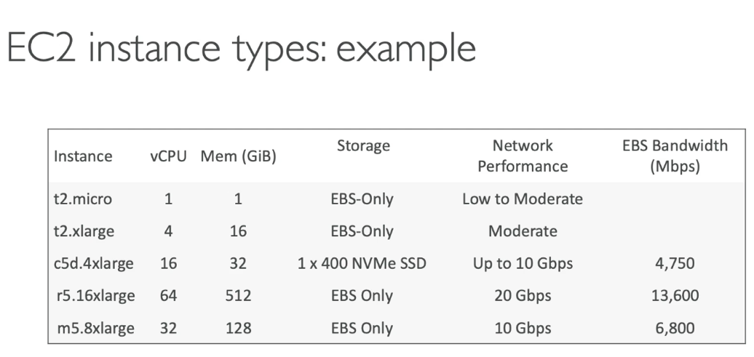

**Create an EC2 Instance:**

Choose region (keeping in mind low latency) – create instance

Step 1: Choose AMI, amazon machine image (s/w configuration required to launch the

instance) – many diff options (1) quick start are AMIs provided by AWS (2) My AMIs where

you can create your own (3) AWS Marketplace or AMIs (4)Community AMIs

Step 2: Choose instance type

Step 3: Configure Instance Details – EC2 User Data

Step 4: Add storage

Step 5: Add Tags

Step 6: Configure security group

Review – launch

Create key/pair and save it carefully!!!

*Notes*: We now have a functioning EC2 instance. It will have a public and private IPv4

address. You can access the instance by pasting the public IP in the browser. If you stop and

restart your instance, public IP will change although private IP will remain same.

**EC2 Instance Types:**

|  |
| --- |
| Eg: m5.2xlarge. Here, m: instance class; 5: generation; 2xlarge: size within the instance class |

* **General Purpose:**

Great for diversity of workloads. Balance b/w compute, memory and networking.

* **Compute Optimized:**

Great for compute intensive tasks that require high performance processors like batch

processing workloads, High performance computing, etc. (c series)

* **Memory Optimized:**

Fast performance for workloads that process large datasets in memory. Use case: High

performance relational/non-relational databases, elastic cache, real time processing of big

unstructured data (r series)

* **Storage Optimized:**

Great for storage intensive tasks that require high sequential read and write access to large

data sets on local storage. Use cases: OLTP systems, Distributed file sys etc. (I, d or h1 series)

**Security Groups and Classic Ports Overview:**

*Security groups* are fundamental to n/w security in AWS

*Security groups* control traffic into and out of EC2

*Security groups* contain only ‘Allow’ rule

*Security groups* rules can be reference by IP or security groups

* Firewall on EC2 instances
* They regulate
  + Access to ports
  + Range of IP – IPv4 or IPv6
  + Control of inbound or outbound n/w

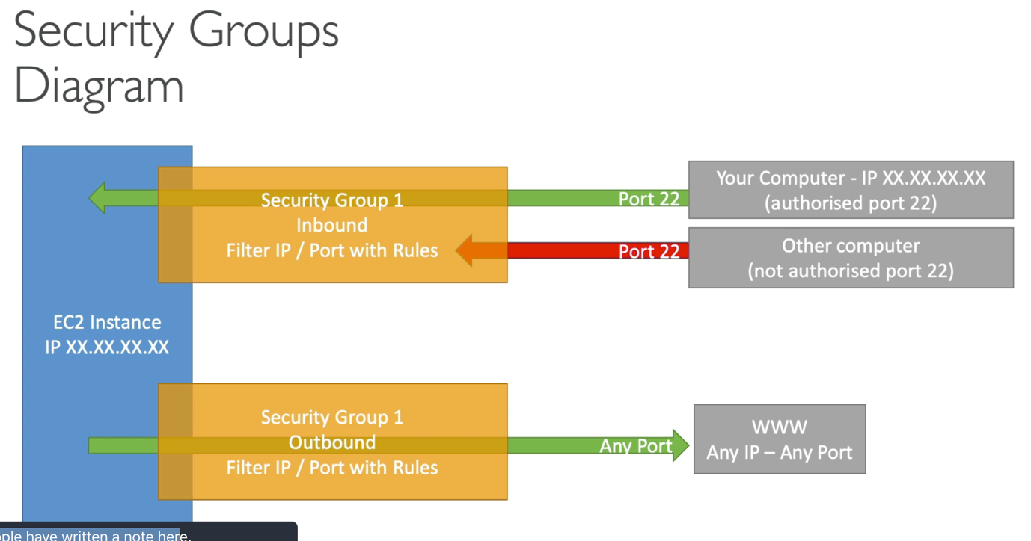

Other Facts:

* Can be attached to multiple instances
* Locked down to region
* Lives outside the EC2 (The instance wouldn’t know traffic is blocked)
* One separate security group for SSH access
* If your application is not accessible (time out) -> security group issue
* By default all in bound traffic is blocked and all outbound traffic is Allowed.

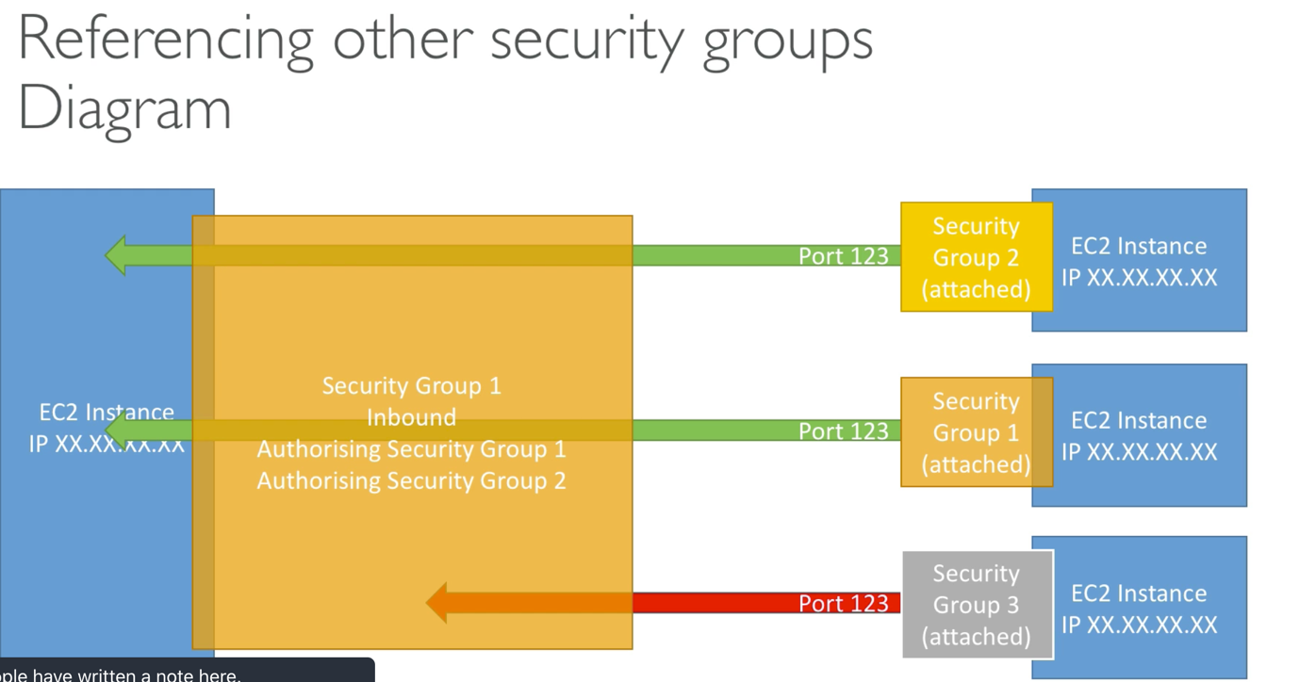

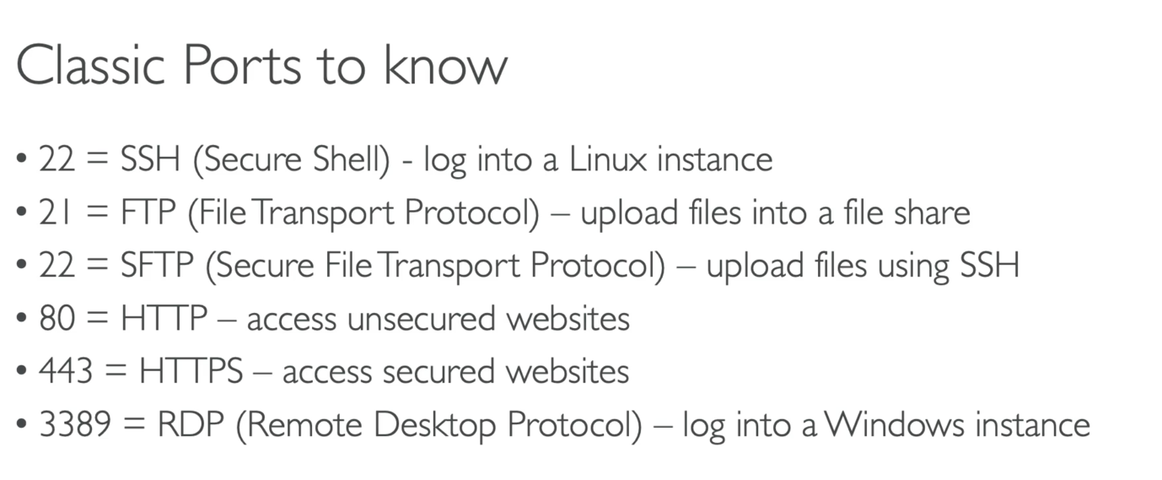

**SSH: [port 22]**

Command line utility (Linux, Mac, windows>10)

Alternates: Putty (All windows); EC2 instance connect (All OS)

Note: Watch video 40 to set up SSH in Mac

Note: permissions 0644 (too open) when first trying to access key file

**EC2 instance connect:**

Directly connects EC2 easily and opens terminal in browser (although behind the scenes this still relies on SSH)

**EC2 Instance Role Demo:**

(never enter your secret access key into EC2 instances) – instead use IAM roles

Go to the instance -> actions -> modify IAM role

**EC2 Instances Purchasing Options:**

**On demand**: Short workload un-interrupted, predictable pricing

**Reserved** (Min 1 year; or 3 years): a. *reserved instance* [upto 75% discount] – long workload, b. *convertible reserved instances* [upto 54% discount]– long workload w flexible instances, c. *scheduled reserved instances* – ex every Thursday 9-10AM.

{pricing: no or partial upfront – some discount; all upfront – max discount}

**Spot instances** [90% discount]: short workloads, cheap, could lose instances.

**Dedicated hosts**: entire phy server; control instance placement. Use when – compliance requirements, reduce costs by allowing you to use your existing server bound s/w licenses, **3 year** period reservation

**Dedicated instances:** No access to dedicated h/w but phy dedicated h/w assigned

**Shared Responsibility model for EC2:**

|  |  |
| --- | --- |
| **AWS** | **Customer** |
| Infrastructure (Global n/w security) | Security group rules |
| Isolation on Phy host | OS patches and updates |
| Compliance Validation | S/W & utilities installed on EC2 instances |
| Replacing faulty h/w | IAM roles assigned to EC2 and IAM user access management |
|  | Data security on your instance |

**SECTION 4: EC2 INSTANCE STORAGE**

**EBS Overview**:

* EBS volume – Elastic block store, is a **network drive** (not physical drive) you can attach to your instance while they run. Allow us to *persist data even after instance terminates*.
* Can only be mounted to one instance at a time. One instance can have 1+ EBS attached
* Bound to specific availability zones – although to move volume across you first need to snapshot it
* Analogy: Network USB stick
* Have a provisioned capacity – you get billed for that

Delete on termination: (this setting can be change, by default true for root volume and false for others) When EC2 instance is terminated, EBS will also be deleted.

**EBS Snapshot Overview**:

* Make a backup (snapshot) of your EBS at any point
* Not necessary to detach volume but recommended before snapshot
* Can copy snapshots across AZ or region

Transfer EBS across AZs:

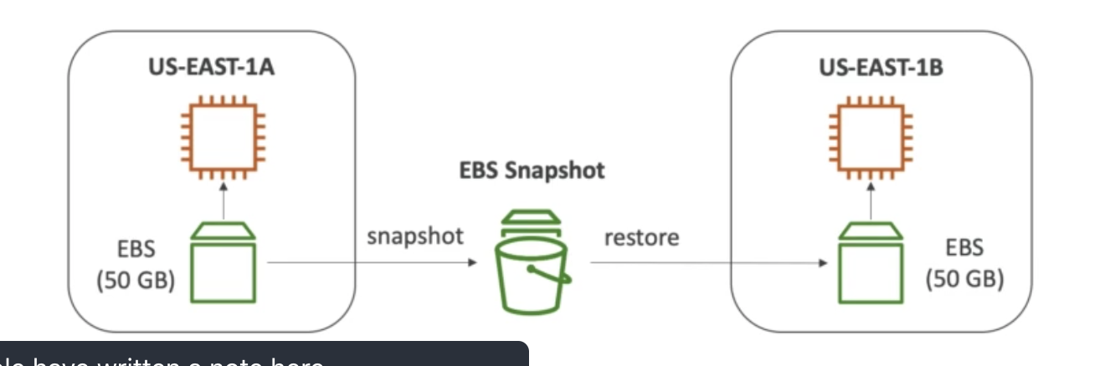

**AMI Overview:**

* Amazon machine image
* Customization of EC2 instances – add your own s/w, configuration, OS, monitoring tools etc; faster boot because all configuration, s/w is already pre-packaged through AMIs
* Region specific but can be copied across regions
* Types: Public – by amazon, Your own AMI, AMI Marketplace

**AMI Process (from an EC2 Instance):**

* Start an EC2 instance and customize it
* Stop the instance (for data integrity)
* Build an AMI – this will also create EBS snapshots
* Launch instances from AMI

{Create EC2 instance – image and templates – create image – use new image to launch EC2 instances}

**EC2 Image builder:**

Automate creation of virtual machines or container images

* Automate the creation, maintain, validate and test EC2 AMIs

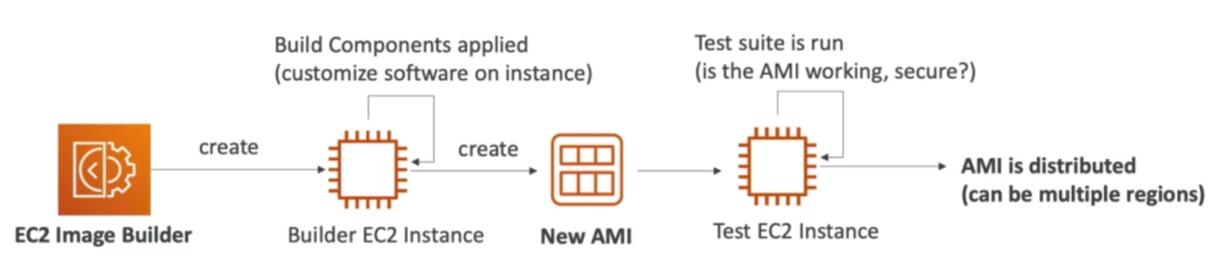

It can be run on a schedule.

Free service.

Notes from Hands on:

Create image pipeline

Build schedule – cron, manual, conditions

Choose/create recipe – AMI, docker

Source image

Components

Infrastructure configuration – attach IAM role

**EC2 Instance Store:**

EBS volumes are network drives with good but limited performance

If you need high performance -> EC2 instance store -> Better I/O performance

Caveat: EC2 instance store lose their storage if they’re stopped (ephemeral)

Good for buffer/cache/scratch data/temporary content

Very High IOPS -> local EC2 instance store

**EFS – Elastic file system:**

* Managed NFS (network file system) that can be mounted on 100s of EC2 at a time
* Linux EC2 – across multi AZ
* Highly available, scalable, expensive, pay per use

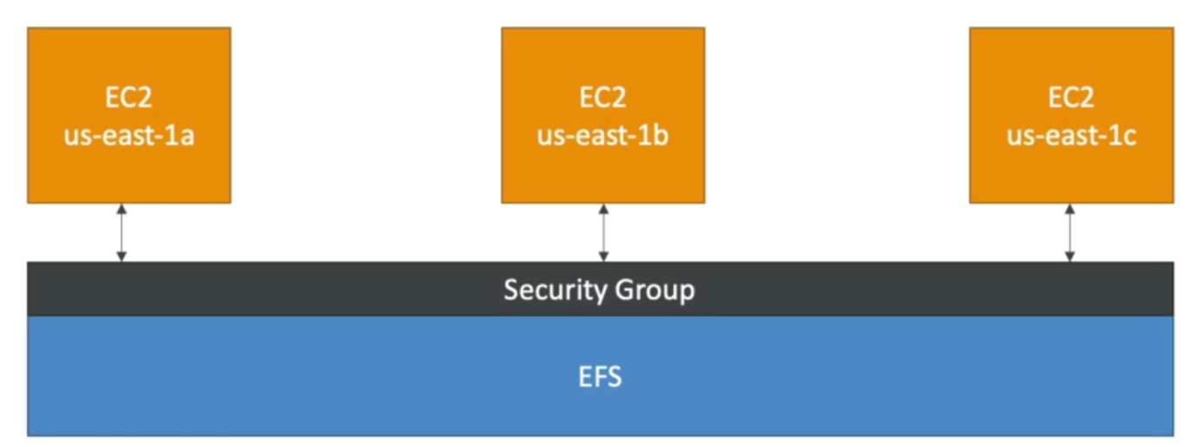

**EBS vs EFS**

Important

EBS – AZ specific

EFS – Multi AZ availability

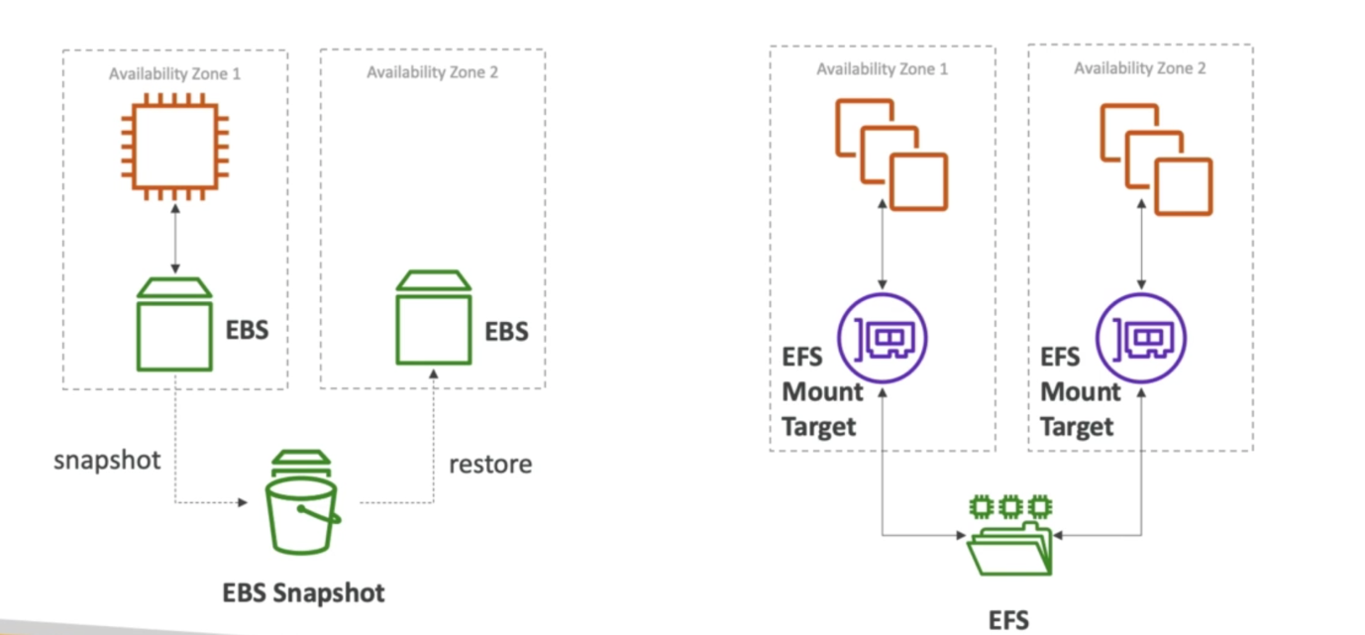

**Shared responsibility Model for EC2 storage:**

|  |  |
| --- | --- |
| **AWS** | **Customer** |
| Infrastructure | Setting up backup/snapshot procedures |
| Replication of data for EBS and EFS (in case h/w crashes) | Setting up data encryption |
| Replicating faulty h/w | Responsibility of ay data on the drives |
| Ensuring their employees can’t access your data | Understand the risks associated with EC2 instance store |

**SECTION 5: ELB AND ASG – ELASTIC LOAD BALANCING & AUTO SCALING GROUPS**

**Introduction:**

Scalability: can handle greater loads. Can be vertical (increase size of instance, there’s a limit) or horizontal (aka elasticity, add more no. of instances, implies distributed systems)

High availability: means running your application in 1+ AZs to survive data loss

**ELB – Elastic Load Balancer:**

* Servers that forward internet traffic to multiple servers (EC2 instances) downstream. Spread load across multiple downstream instances.
* Expose a single point of access (DNS) to your application
* Seamlessly handle failures. If an instance fails, can be redirected to another w/o system crashing
* Does regular health checks of your instances
* Provide SSL termination (HTTPS) for your websites
* High availability across zones
* Managed load balancer – handled by AWS. Types: (1)application – http/https only - layer 7; (2) network – **ultra high performance**, allows TCP – layer 4; (3) classic - layer 4 and7; (4) gateway

Notes from hands on:

Target group – group instances to balance load

Health checks – help keep the system running even in case of failure

**ASG – Auto Scaling Group:**

Load on website can change overtime and in cloud we can create and get rid of servers v quickly SOOO, goal of ASG is:

* Scale out and in to match increase/decrease in load
* Ensure we have a **min and max no. of instances running**
* Automatically **register new instances with load balancer**
* *Replace unhealthy instances*
* Cost saving: only run at optimal capacity

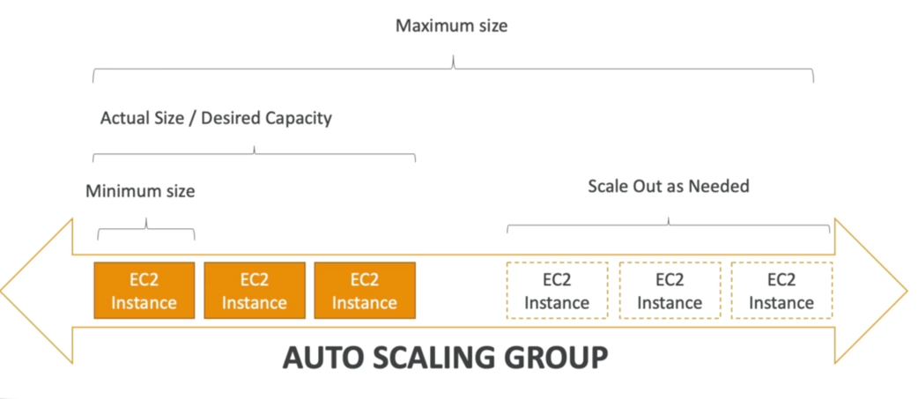

Works in sync with ELB. As we scale in or scale out ELB distributes the load equally

Notes from Hands on:

Launch template – all settings in EC2

ASGs can’t change instance type

**SECTION 6: S3**

**Overview:**

* Infinitely scaling storage
* Use cases:
* Backup and storage
* Disaster recovery
* Archive
* Hybrid cloud storage
* Media hosting
* Data lakes and big data analytics
* Software delivery
* Static website
* In s3 we store objects (file) in buckets (directories)
* Buckets must have a globally unique name (across all regions and accounts)
* Looks like global service but buckets created in region
* *Naming convention*: no uppercase, no underscore, 3-63 char, not an IP, must start w lowercase or number
* Objects (files) have keys (FULL path)
* No concept of directories
* Max size 5k GB, although for uploading more than 5GB use multi part upload

**Bucket Policy:**

S3 security –

User based: IAM policies (which API calls should be allowed for specific user from IAM console)

Resource based: Bucket wide rules from s3 console – across accounts

Object access control list – finer grain

Bucket Access control list – less common

Encryption using encryption keys

Different accesses

Public Access – bucket Policy: So a user can access objects in ay bucket

User Access (IAM) – IAM policy

EC2 instance access – IAM roles

Cross account access – bucket policy

S3 bucket policy:

* JSON based policies (aws policy generator)

{resources – buckets and objects; Actions – set of API to allow/deny; Effect – allow/deny; principal – account or user to apply policy to}

* Use bucket policies for grant public access, force objects encryptions at upload, cross account access
* Block public access settings set true by default (settings to be changed if you want to make it public)

**S3 website overview:**

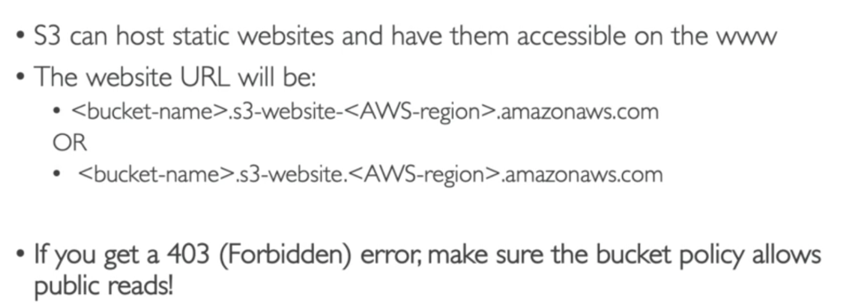

**S3 Versioning:**

Enabled at version level.

Any time you update your file, you’ll get a version.

Advantages:

* You’re protected against unintended deletes (ability to restore a version)
* Easy rollback to previous version (just delete latest version)
* Any file that is not versioned prior to enabling versioning will have version “null”
* Suspending version does not delete the previous versions
* If you delete only version, it’ll give the object a delete marker and can be restored

**S3 Access Logs:**

* For audit purpose, you may want to log all access to s3 buckets
* Any request made to S3, from any account, unauthorized or denied, will be logged into another S3 bucket
* That data can be analyzed using data analysis tools
* Very helpful to *come down to root cause of an issue*, or *audit usage*, *view suspicious patterns, etc.*

**S3 Replication (CRR and SRR):**

If you want the contents of one bucket to be continuously copied to anther bucket in same region (SRR) or cross region (CRR) you can set replication.

* For this you must enable ***versioning in source and destination***
* Copying is asynchronous behind the scenes
* Must give proper IAM permissions to S3

CRR – Use cases: compliance, lower latency access, replication across accounts

SRR – Use cases: Log aggregation, live replication between production and test accounts

Application before replication is enabled are not copied.

**S3 Storage classes Overview:**

Amazon S3 standard – General purpose storage class

Amazon S3 standard – Infrequent Access

Amazon S3 One zone – Infrequent Access

Amazon S3 Intelligent Access

Amazon S3 Glacier

Amazon S3 Glacier deep archive

Durability: how often you’ll lose your files. All storage classes have a durability of

99.99999999999

Availability: How readily services are available. S3 standard has availability of 99.99%.

* Amazon S3 standard – General purpose storage class:

99.99% availability

Used for infrequently accessed data

Low latency, high throughput

Sustain 2 concurrent failure

Use case: Big data analytics, mobile and gaming applications, content distribution

* Amazon S3 standard – Infrequent Access

**Less frequent accessed** but requires **rapid access when needed**

99.9% availability

Lower cost compared to S3 standard, but retrieval fee

Sustain 2 concurrent failure

Use case: As a data store for disaster recovery, backup (which you know you won’t access very often)

* Amazon S3 Intelligent Access

99.9% availability

Low latency, high throughput – same as s3 standard

Cost optimized by automatically moving objects between 2 access tiers based on changing access patterns:

* + - Frequent access
    - Infrequent access
* Amazon S3 One zone – Infrequent Access

Same as IA but data is stored in single AZ

99.5 availability

Low latency, high throughput – same as s3 standard

Even lower cost compared to S3-IA (by 20%)

Use cases: storing secondary backup copies of on-premise data, storing data you an recreate

* Amazon S3 Glacier and Glacier deep archive

Low cost object storage meat for archiving/backup

Data retained for longer term (years)

Various retrieval options of time + fees for retrieval

*Glacier: cheap*

Expedited (1-5 mins)

Standard (3-5 hours)

Bulk (5-12 hours)

*Glacier deep archive: cheapest*

Standard (12 hours)

Bulk (48 hours)

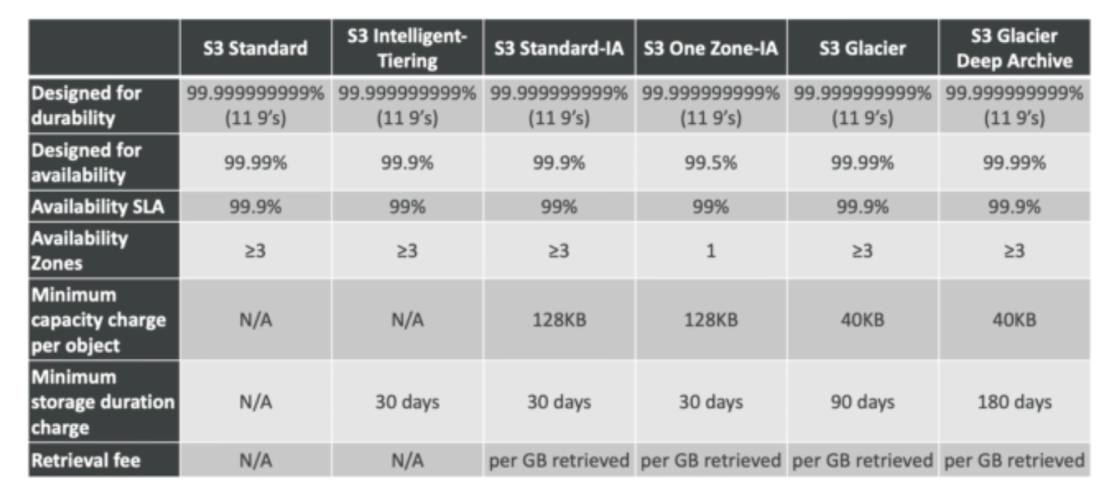

*S3 – moving between storage classes*

You can transition objects between storage classes. Moving objects can be automated using a lifecycle configuration.

**S3 Object Lock & Glacier Vault Lock:**

*S3 object Lock*: adopt a WORM (write Once Read Many) model

Block an object version deletion for a specified amount of time

*Glacier Vault Lock*: WORM model

Lock the policy for future edits (can no longer be changed)

Helpful for compliance and data retention

**Shared Responsibility Model for AWS S3:**

|  |  |
| --- | --- |
| **AWS** | **Customer** |
| Infrastructure (Global security, durability, availability, sustain concurrent loss of data in 2 facilities) | S3 versioning, bucket policies, replication setup |
| Configuration & vulnerability analysis | Logging and monitoring |
| Compliance validation | Cost optimal storage class and data encryption at rest and in transit |

**AWS Snow Family:**

* Highly secure portable devices to – collect and process data at the edge or migrate data into and out of AWS
* Data migration: Snowcone, Snowball edge, Snowmobile
* Edge computing: snowcone, Snowball edge

Why do data migration with AWS Snow Family?

It takes a lot of time to transfer data over a network line. Other challenges: limited

connectivity and bandwidth, shared bandwidth, connectivity stability, high network cost

Snow family is an offline device that performs data migrations. If it takes more than a week to transfer data over the network, use snow family.

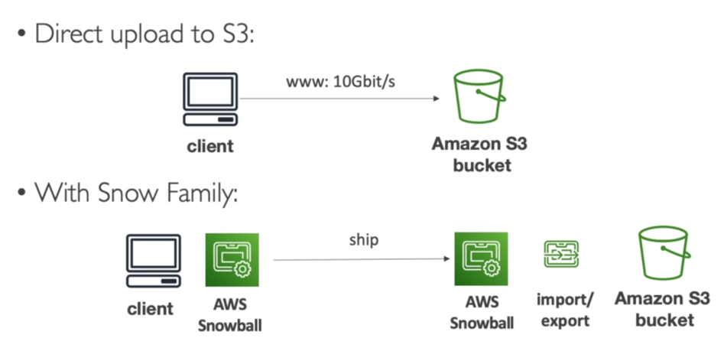

*Snowball edge:*

* Physical data transport solution: move TBs or PBs of data in or out of AWS
* Alternative to moving data over the n/w (and paying n/w fees)
* Pay per data transfer job
* Provide block storage and amazon S3-compatible object storage
* Snowball edge storage optimized

80 TB of HDD capacity for block volume and s3 compatible object storage

* Snowball edge Compute optimized

42 TB of HDD capacity for block volume and s3 compatible object storage

* Use cases: large data cloud migration, decommission data center, disaster recovery

*Snowcone:*

* Small portable computing, rugged and secure, withstands harsh environments
* Light (2.1 kgs)
* Device used for edge computing, storage and data transfer
* TBs of usable storage
* Use snowcone when snowball doesn’t fit. Must provide own battery/cables.
* Can be sent back to AWS offline or connect it to internet and use AWS datasync to send data

*Snowmobile:*

* An actual truck. Transfer exabytes of data.
* Each mobile has 100PB of capacity
* High security: temperature controlled, GPS, 24/7 video surveillance
* Better than snowball if u have to transfer >10PB

*Usage process:*

Data migration:

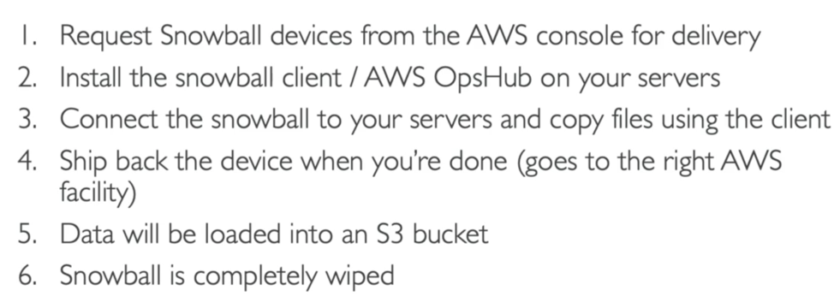

Edge computing:

Process data while it’s being created on an edge location (locations where data might be produced but no/limited internet access, computing power)

For this we have snowcone, snowball edge.

Use cases for edge computing:

* Preprocess data
* ML at the edge
* Transcoding media streams

*Snowcone* –

2 CPUs, 4GB memory, wired or wirerless access

USB-C power

*Snowball edge – compute optimized*

52vCPUs, 208GiB RAM, Optional GPU, 42 TB useful storage

*Snowball edge – storage optimized*

Upto 40 vCPUs, 80GiB RAM

All can run EC2 instances and AWS lambda functions (using **AWS IoT greengrass)**

Long term deployment options – 1 and 3 years discounted pricing

AWS OpsHub:

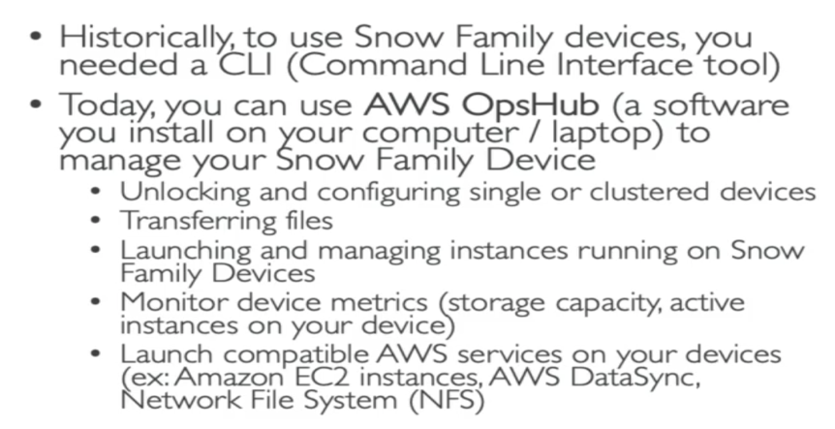

**Storage gateway option:**

Hybrid cloud for storage – bridge between on premise and cloud

This can be due to:

* Long cloud migrations
* Security requirements
* IT strategy
* Compliance requirements

S3 is a proprietary storage technology (unlike NFS/EFS), so how do you expose the s3 data on premise? **AWS storage Gateway**

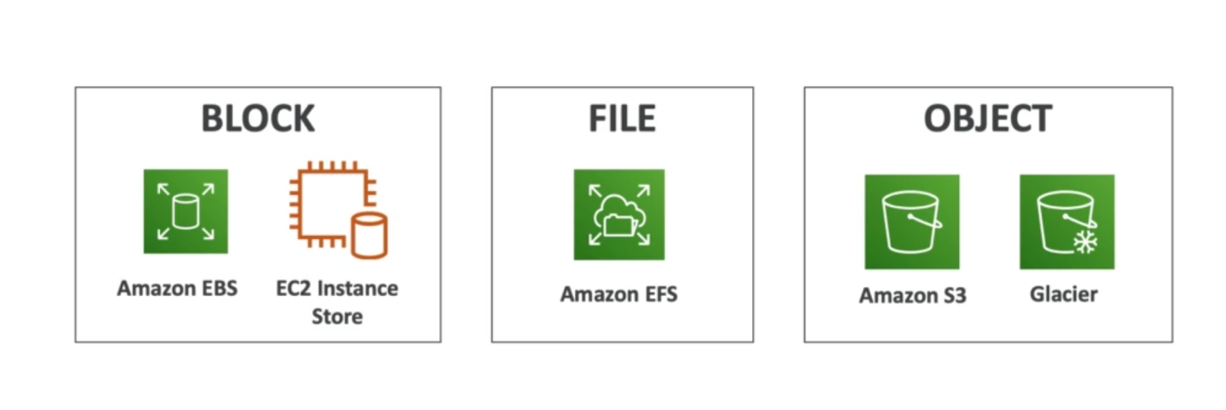

Where does storage gateway fit into all of this? It is a bridge between on premise and cloud data in s3

Hybrid storage service to allow on premises to seamlessly use the AWS cloud

*Types of gateway*: File, volume and tape

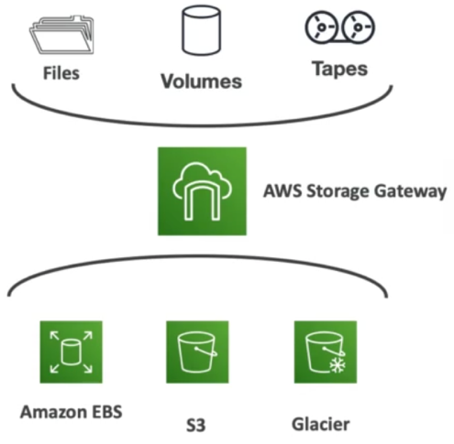

**SECTION 6: DATABASES AND ANALYTICS**

**Databases Introduction:**

Storing data on disk (EFS, EBS, EC2 instance store, S3) -> have limits

Sometimes, you can store data in a database: structure the data, efficiently query/search your data, define relationship b/w your datasets

*Relational DB*: (like excel spreadsheets, with links between different datasets)

SQL language for queries/lookups

*NoSQL = non-SQL = non relational databases*

Build for a specific purpose

Benefits: flexible schema, scalable, high performance, high functional

Eg: JSON

**Databases & Shared Responsibility model on AWS:**

AWS offers to manage different db

Benefits:

* Quick provisioning, high availability, vertical, horizontal scaling
* Automated backup & restore, operations, upgrades
* OS patching handled by AWS
* Monitoring, alerting

**RDS (Relational DB Service) & Aurora Overview:**

RDS:

* **Managed** DB service, uses SQL as a query language
* Allows you to create db in the cloud, managed by AWS: Postgres, MySQL, MariaDB, Oracle, Microsoft SQL Server, Aurora (AWS proprietary db)
* Benefits:
* Automated, OS patching
* Continuous backups and restore
* Monitoring dashboards
* Read replicas for improved read performance
* Multi AZ setup for disaster recovery
* Maintenance windows for upgrades
* Scaling capability
* **Storage backed by EBS**

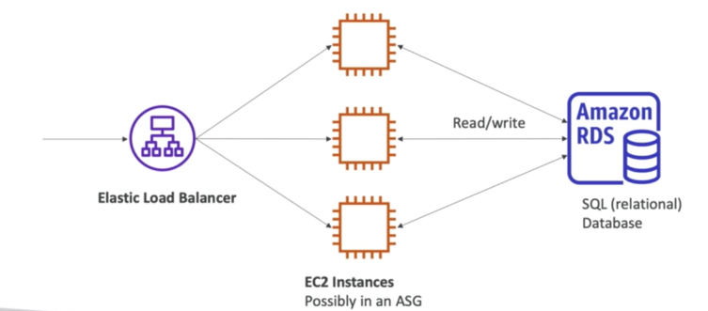

**Aurora:**

Not open source

Cloud optimized: 5x performance (MySQL), 3x (Postgres)

**Storage grows automatically in increments of 10GB, up to 64TB**

More efficient than RDS

**RDS Deployment Options:**

* Read replicas:

Replicas of RDS DB to allow your application to read from replicas also so the reads are distributed. Up to **15 replicas** can be created.

Writing can be done only to the OG RDS.

* Multi AZ:

Failover in case of AZ outage (high availability). Replication in a different AZ.

* Multi region:

Replica in different region  
Application in different region can read from the closest replicas. But write happens to OG RDS. Why use this? Disaster recovery, low latency

Replication cost

**ElastiCache Overview:**

* It is to get managed Redis or Memcached
* Caches are in memory databases w high performance, low latency
* Helps reduce load off databases for read intensive workload
* AWS takes care of OS maintenance, patching, optimizations, setup, configuration, monitoring, failure recovery & backups

*Solution Architecture:*

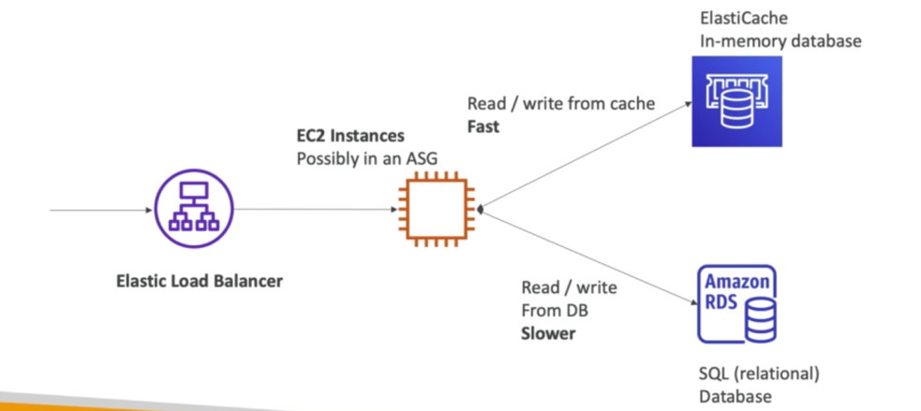

**Dynamo db:**

* Fully **managed**, highly available db with replication across **3 AZs**
* **No SQL** db – not relational
* ***Serverless*** db, scales to massive workloads
* Very low latency (single digit milli second latency)
* Autoscaling, low cost
* IAM security
* It’s a key/value db

**DAX**: In memory cache for dynamo db. Secure, scalable and highly available

**Redshift:**

Database based on PostgresSQL (not for OLTP) but for **OLAP** (analytics and warehousing)

* Data loaded **every hour not second**
* 10x better performance than other warehouses
* **Columnar storage** of data (instead of row based)
* Massively **Parallel Query Execution**
* Pay as u go
* Has a SQL interface for performing the queries
* **BI tools** such as aws quicksight or tableau integrate w it

**EMR:**

Elastic Map Reduce

* EMR helps creating Hadoop clusters (big data) to analyze and process vast amounts of data
* When using EMR – u can use clusters made of 100s of EC2 instances
* Also supports Apache spark, HBase, presto
* EMR takes care of provision and configuring all EC2 instances
* Auto scaling and integrated 2 SPOT INSTANCES
* Use cases: data processing, ML, web indexing, big data

**Athena:**

Serverless db with SQL capabilities

* Used to query data in S3
* Pay as per query
* Output results back to S3
* Secured through IAM
* Use case: one-time SQL queries, serverless queries on S3, log analytics

**QuickSight:**

**Serverless ML powered BI service** to create interactive dashboards

* Fast, automatically scalable, embeddable, with per-session pricing
* Use cases:
* Business analytics
* Building viz
* Perform ad hoc analysis
* Get business insights using data
* Integrated with – **RDS, Aurora, Athena, S3**

**DocumentDB:**

Aurora – aws implementation of postgres,MySQL

DocumentDB – Same for mongoDB (noSQL)

* Used to store, index and query JSON data
* Similar deployment concept as aurora
* Fully managed, highly available, replication across 3 AZ
* Automatically scales to workload w millions of requests/second

**Neptune:**

Fully managed, graph db (eg: social network)

* Replication across 3 AZ, highly available
* 15 Read replicas
* Build and run applications working with highly connected datasets – optimized for complex queries
* Can store up to billions of relations and query the graph w milliseconds latency
* Use cases: knowledge graph (Wikipedia), fraud detection

**QLDB:**

Quantum ledger DB

* Fully managed, serverless, highly available, replication across 3 AZs
* **Used to review all changes made to your application data over time**
* **Immutable system**: no entry can be removed or modified, cryptographically verifiable
* 2-3x better performance, manipulate data using **SQL**
* **No concept of decentralization** (unlike amazon blockchain)

**Managed Blockchain:**

It makes possible to build applications where multiple parties can execute transactions w/o

the need of a trusted, central authority

Managed service to:

* Join public blockchain n/w
* Decentralized blockchain
* Create your own scalable private n/w
* Compatible w -> **Hyperledger and Ethereum**

**DMS:**

Database migration service

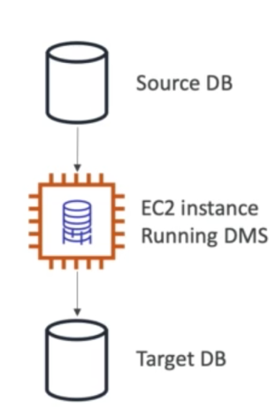

* Quickly and securely migrate db to AWS, resilient, self-healing
* Source db remains available during migration
* Supports: homogeneous (oracle to oracle) ad heterogeneous (Microsoft SQL server to aurora) migration

**AWS Glue:**

**ETL**: v helpful when you have datasets that you need to pre process and transform the data

* Fully serverless
* Useful to prepare data and transform data for analytics

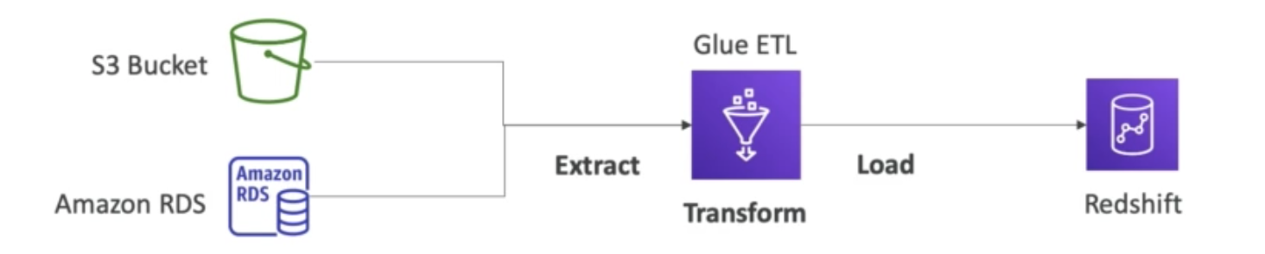

***Glue data catalog****: catalog of datasets in your AWS infrastructure. Can be used by Athena, Redshift and EMR to build proper Schemas for the datasets.*

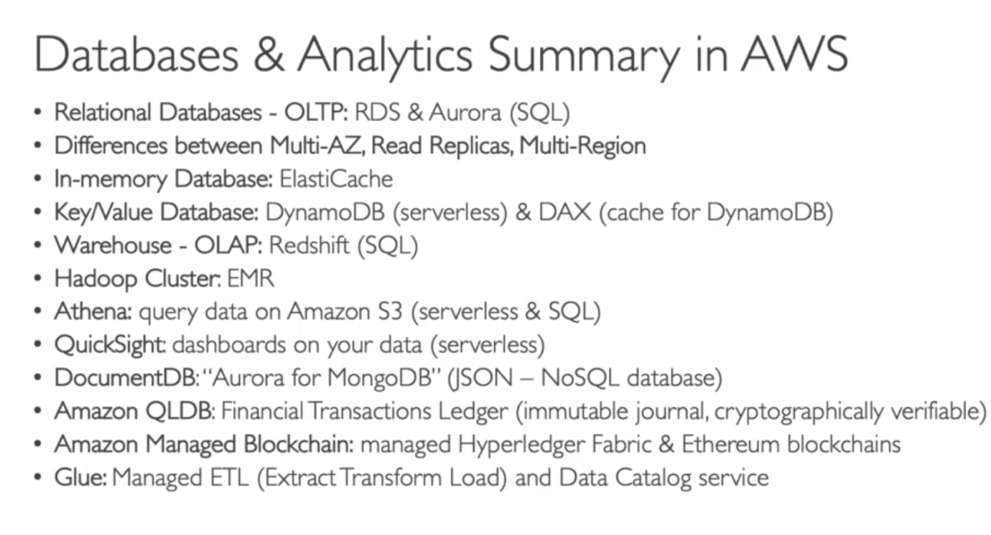

**SECTION 7: COMPUTE SERVICES: ECS, LAMBDA, BATCH, LIGHTSAIL**

**Docker:**

* Software development platform to deploy apps
* Apps are packaged in containers that can be run on any OS
* Apps run the same, regardless of where they’re run: any machine, no compatibility issues, predictable behavior, less work, easier to maintain ad deploy, works with any language
* Scale containers up and down very quickly

Where docker images stored? Docker repositories

ECR: private docker hub by AWS

Dockers VS Virtual Machines:

* Dockers are sort of Virtualization technology
* Resources are shared with host => many containers on one server

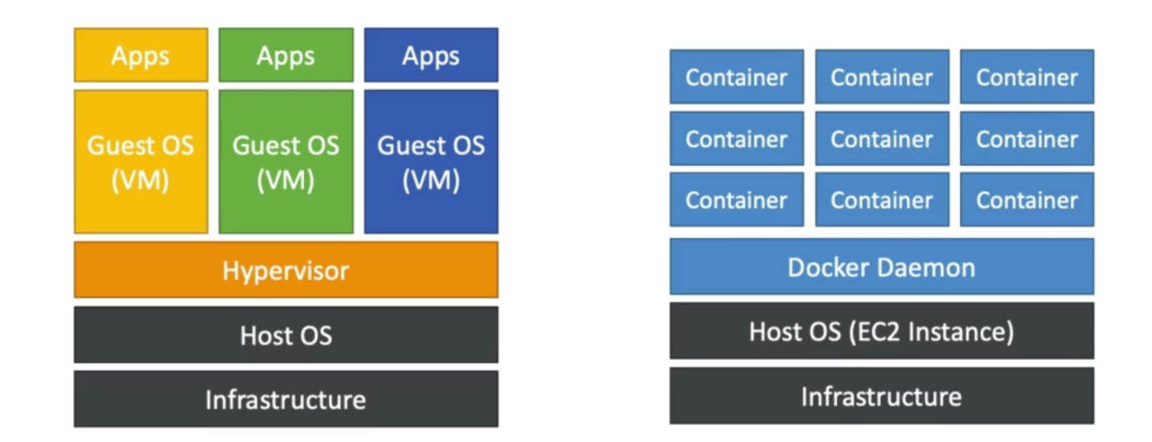

**ECS (Elastic Container Service):**

* Launch **docker container on AWS**
* You must provision an maintain the infrastructure -> the EC2 instances
* AWS takes care of starting/stopping containers
* Has integrations with Application Load balancer

**Fargate:**

* Launch docker container on AWS
* No need to provision EC2 instances (**serverless**)
* AWS just runs containers based on CPU/RAM you need

**ECR (Elastic Container Registry):**

Storing docker images – container registry

* This is where you can store your docker images so they can be run by ECS or Fargate
* Fargate/ECS looks at images in ECR and create containers

**Serverless Introduction**:

* When developers don’t have to manage servers. They just deploy code (functions)
* Serverless == Faas (functions as a service)
* Serverless doesn’t mean no servers - > you just don’t need to provision/manage them
* Ex: S3, DynamoDB, Fargate, Athena, Lambda (pioneer of serverless services)

**Lambda:**

*So with EC2* - > they are servers in cloud and are limited by RAM and CPU. They are

continuously running and to scale you have to intervene.

*With Lambda* -> Virtual functions – no servers to manage, limited by time (short executions),

Run, on-demand, scaling is automated.

Benefits:

* Easy pricing: pay per request and compute time
* Integrated w AWS suite of services
* Event driven (reactive service): fncs get invoked by AWS when needed
* Integrated with many programming languages (python, nodejs, c#, golang etc)
* Easy monitoring w cloudwatchh
* Easy to get more resources per function

**Lambda container image**: Allows to run actual docker containers on top of lambda, the

images **must implement lambda runtime API**

Use case: Thumbnail creation service

Upload picture -> s3 -> lambda ->s3 (compressed picture)

Use case: serverless CRON job (LINUX machine)

*Pricing:*

First 1M lambda invocation are free

Pay per calls at 0.2$ per 1M request

Very cheap, very popular

Pay for duration

Min duration to be billed for = 100ms

**API Gateway:**

Uses case: build a serverless HTTP API

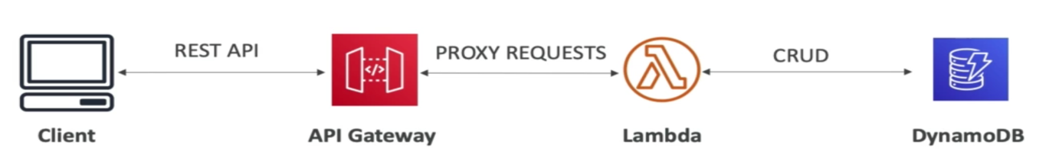

Fully managed, serverless, scalable, supports RESTful and WebSocket APIs

Supports for security, API keys, monitoring etc

**Batch Overview:**

* Fully managed batch processing service at any scale
* Batch job – has a start and end (not continuous)
* Batch will dynamically launch EC2/Spot instances
* Batch will provision right amount of compute/memory
* You submit or schedule batch jobs, Batch does the rest
* Batch jobs are defined as **docker images** and run on **ECS**

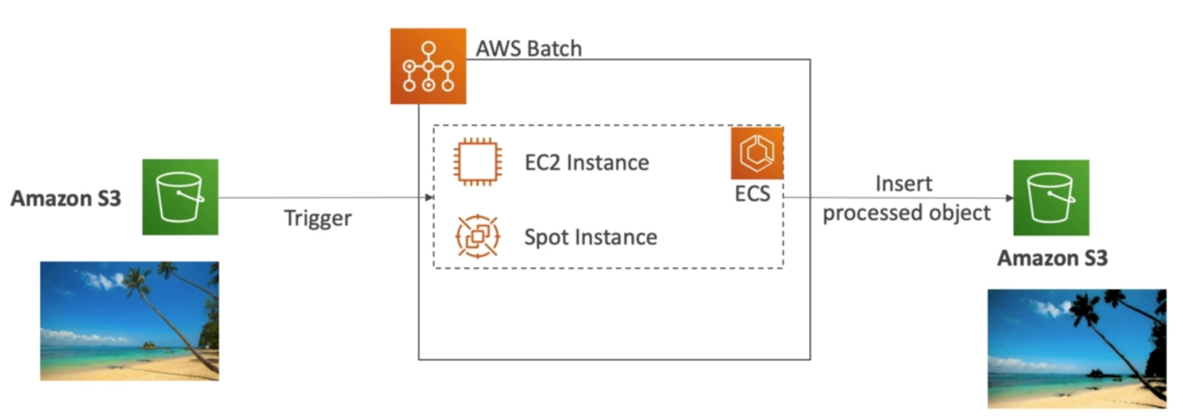

Batch vs Lambda:

Lambda:

* Time limit (15 mins)
* Limited runtimes
* Limited temporary disk space
* Serverless

Batch

* **Not serverless** (relies on EC2)
* No time limit
* Any runtime as long as its packaged as docker image
* Rely on EBS/instance store for disk space

**Lightsail:**

* Virtual servers, storage, db, and networking in one place
* Low and predictable pricing
* Simple alternative to EC2, RDS, ELB, EBS, Route 53…
* Can set up notifications
* For people w limited cloud experience
* Use case:
* Simple web applications
* Websites
* Dev/test environments
* High availability but limited integrations

(Separate service)

**SECTION 8: DEPLOYING AND MANAGING INFRASTRUCTURE AT SCALE**

**CloudFormation:**

* It’s a declarative way of outlining your AWS infra, for ay resource
* For example: you can specify that you need
* A security group
* EC2 instance
* S3 bucket
* ELB in front of these machines

Then CloudFormation will create these in the right order with the exact configuration that you specify.

Benefits:

* **Infrastructure as code** (excellent for control)
* Cost: each resource within the stack will get tagged so you can see how much each stack costs
* Saving strategy: you can automate the deletion of templates at certain time
* Productivity: automated generation of diagrams for your templates; declarative programming
* Don’t re-invent the wheel (use existing templates)
* Supports all AWS services

CloudFormation **Stack designer:**

Creates a diagram and the **relation** between all **resources.**

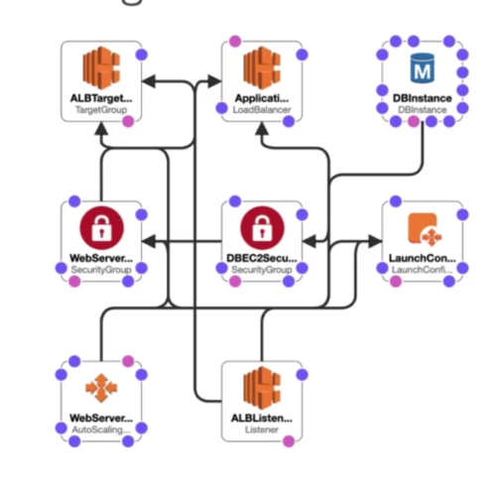

**Beanstalk:**

Web App 3 tier architecture

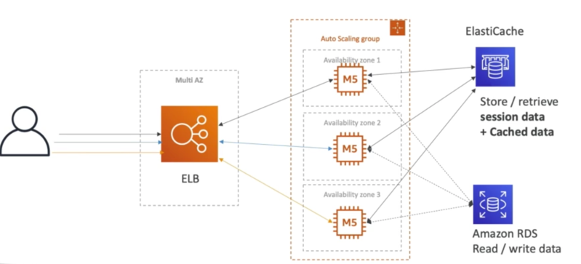

Developer on AWS don’t want to waste time managing infra, scaling concerns, configuring

db, load balancers etc. They just want to be able to deploy their code.

Most web Apps have the same architecture (ELB+ASG), all developers just want to run their

code. Here comes **Elastic Beanstalk**. (Paas)

* It’s a developer centric view of deploying an application on AWS
* It uses all the components we’ve seen before: EC2, ASG, ELB, RDS
* But it’s all in one view that’s easy to make sense of!
* We still have control over the configuration
* Managed service
* Free service, you pay for underlying services
* Three architecture models: single instance deployment (good for dev); LB+ASG (great for production or pre-production web applications); ASG only (great for non-web apps in production)
* Support for many languages/platforms. You can also write your own platform
* **Health monitoring service available**. (cloudwatch)
* Uses cloudformation

**CodeDeploy:**

* We want to deploy our application automatically
* DOESN’T use beanstalk/CloudFormation
* Works w EC2 instances and On-premise servers: **Hybrid service**

**CodeCommit:**

* Before pushing the application code to servers, it needs to be stored somewhere
* It’s like github
* Source control service that hosts git repositories
* Makes it easy to collaborate with others on code
* Code changes automatically **versioned**
* Fully managed, scalable and highly available, private, secure, integrated with AWS

**CodeBuild:**

* Code building service in cloud - like jenkins
* **Compiles source code, run tests and produce packages** that are ready to be deployed (by CodeDeploy for example)
* Benefits: fully managed, serverless, scalable and highly available, secure, pay as you go pricing

**CodePipeline:**

* Something to connect the build and deploy
* Basis for CICD
* Orchestrate the different steps to have the code automatically pushed to production
* Benefits: Fully managed, compatible w CodeCommit, CodeBuild, CodeDeploy, Elastic beanstalk etc
* **Fast delivery and rapid updates**

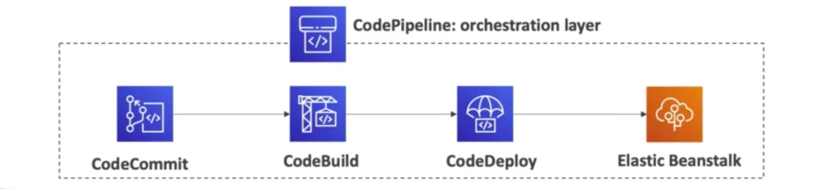

**CodeArtifact:**

* Software packages depend on each other to be built (code dependencies) and new ones are created
* Storing and retrieving these dependencies is called artifact management
* Traditionally you need to setup your own artifact management system
* CodeArtifact does artifact management. Secure, scalable and cost effective
* Works with common dependency management tools like Maven, Gradle, npm, yarn, twine, pip etc
* Developers and CodeBuild can retrieve dependencies straight from CodeArtifact

**CodeStar:**

* Unified UI to easily manage software development activities in one place
* “quick way” to get started to correctly set up codecommit, code pipeline, codebuild, code deploy, elastic beanstalk, EC2 etc
* **Can edit the code “in the cloud” using AWS cloud9**

**Cloud9:**

* Cloud IDE for writing, running and debugging code in the cloud. On web browser.
* Code collaboration

**Systems manager (SSM):**

* Helps you manage your EC2 and on premise systems at scale: **hybrid service**
* Get *operational insights* about state of your infra
* Suite of 10+ products
* Features:
* **Patching automation** for enhanced compliance
* Run commands across entire fleet of servers
* Store parameter config w SSM parameter store
* Works for Linux and windows

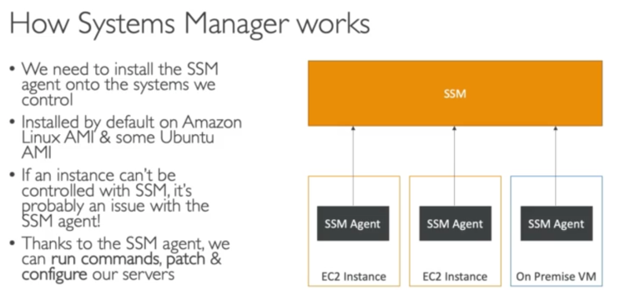

**AWS OpsWorks:**

* Chef and puppet help you perform server config automatically, or repetitive actions
* Alternative to SSM
* AWS OpsWorks = managed Chef and Puppet
* Work well with hEC2 and on premise servers
* Only provision standard AWS resources
* OpsWorks Architecture:

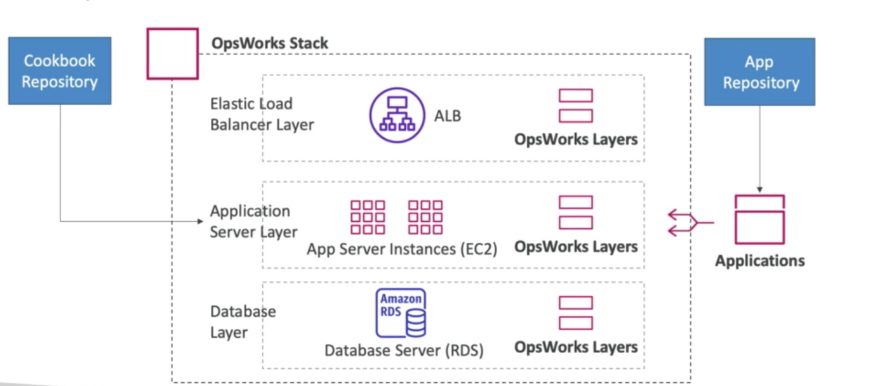

**SECTION 9: GLOBAL INFRASTRUCTURE**

**Why Global Applications?**

* An application deployed in multiple regions or edge location (points of presence) -> decreased latency for users around the world
* Disaster recovery plan (DR plan)
* Attack protection: distributed global infrastructure is harder to attack
* **Global DNS: route 53**
* Global content delivery**: CloudFront**
* S3 Transfer acceleration
* AWS Global accelerator

**Route 53:**

* Managed DNS
* Collections of rules & records which helps clients understand how to reach a server through URLS

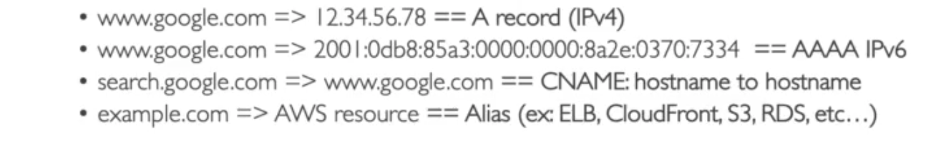

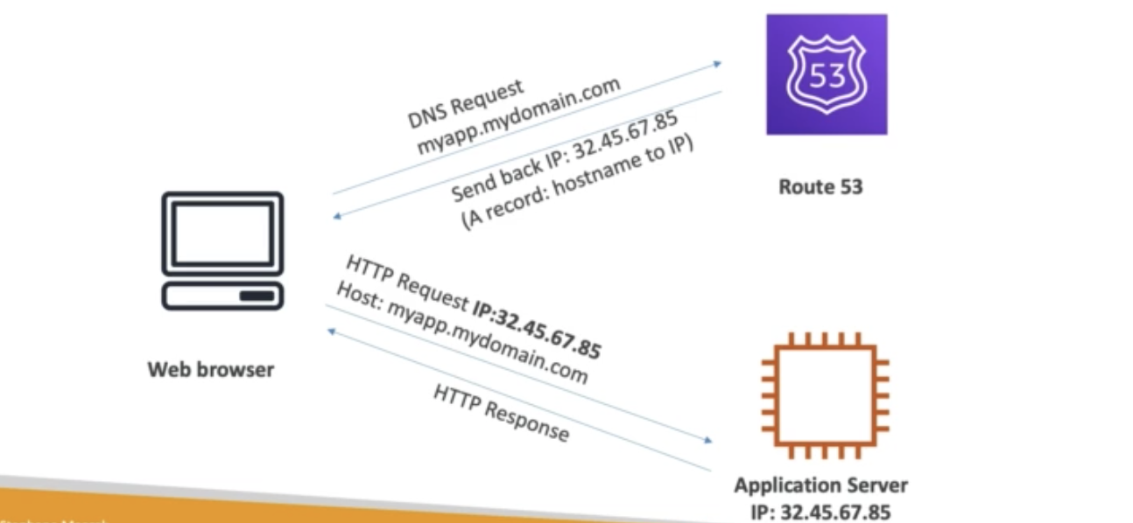

Routing policies:

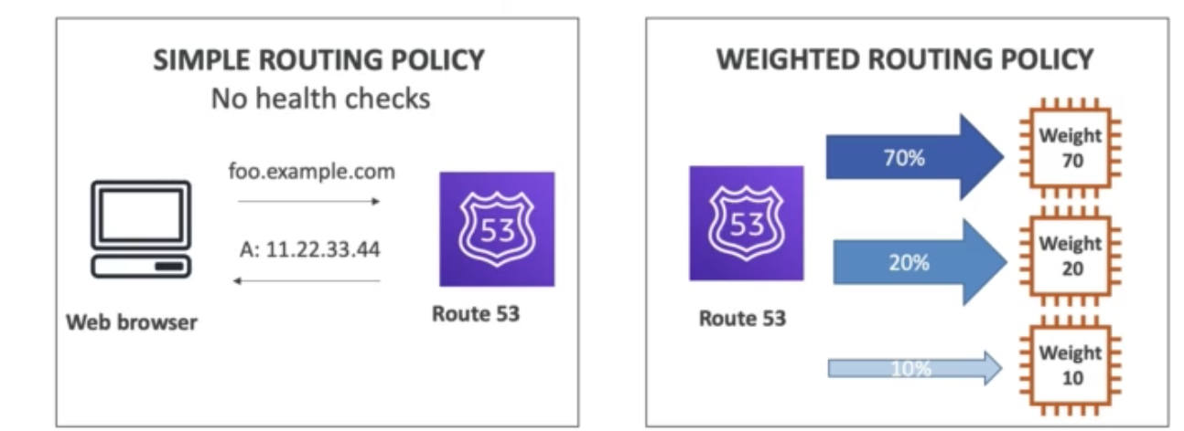

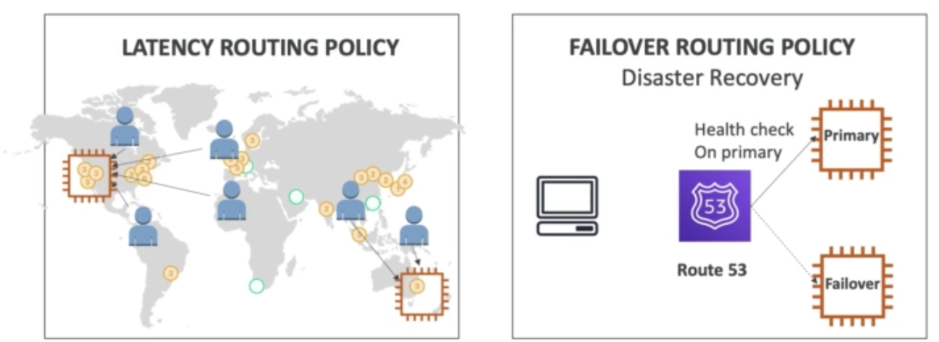

* Except for simple routing policy, all other have health checks
* Not free
* Global service

**CloudFront:**

* Cloud delivery network
* Improves read performance, **content is cached at the edge**
* Improves user experience
* 216 points of presence globally (edges)
* DDos protection (because worldwide), integration with shield, AWS Web Application Firewall
* CloudFront can cache S3 buckets: OAI (origin access identity), can be used as an ingress to upload s3 files
* Custom origin (HTTP)

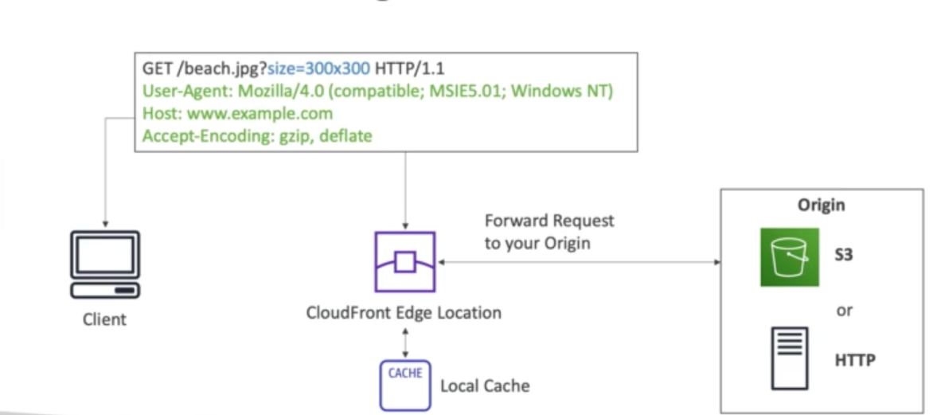

CloudFront v/s cross region replication:

CloudFront:

* Global edge n/w
* Files are cached for a TTL (maybe a day)
* Great for static content that must be available everywhere

Cross Region Replication:

* Must be setup for each region you want replication to happen
* Files updated in near real-time (not cached
* Read only
* Great for dynamic content that need to be available at low latency

**S3 Transfer Acceleration:**

* Increase transfer speed by transferring files to an AWS edge location which will forward the data to the S3 bucket in target region

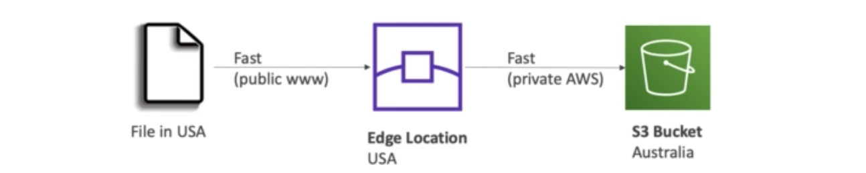

**AWS Global Accelerator:**

* It is used to improve global application availability and performance using the AWS Global n/w
* Leverage the AWS internal n/w to optimize the route to your application (60% improvement)

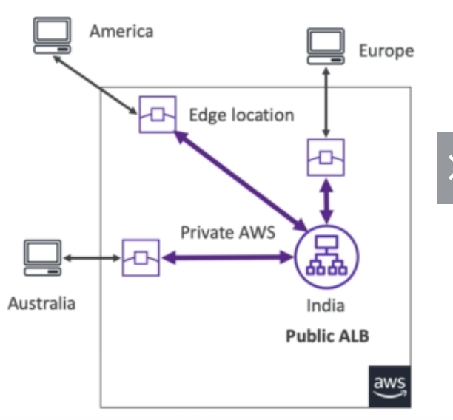

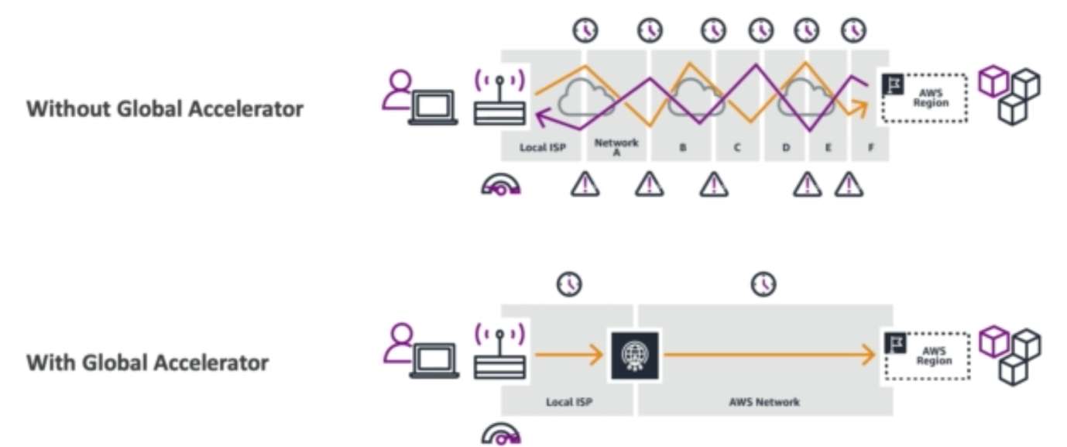

CloudFront V/S AWS Global Acc

Similarities:

* They both use AWS global n/w and its edge locations around the world
* Both services integrate with AWS shield for DDoS protection

Differences:

* CloudFront – content delivery network
* Improves performance for your cacheable content
* Content is served at edge
* Global Accelerator
* No caching, proxying packets at edge to applications in one or more AWS regions
* Improves performance for a wide range of applications over TCP/UDP
* Global HTTP use case that require static IP addresses, fast regional failover

**AWS Outposts:**

* **Hybrid clouds**: on premise + cloud infrastructure
* Need Two ways of dealing w IT systems – one for AWS and then one for on premise
* AWS Outposts are **server racks** that offers the same AWS infra services, APIs & tools to build your own applications on premise just as in the cloud
* AWS will setup and manage “**outposts racks**” within your on-premises infra & you can start leveraging AWS services on premises
* You are responsible for physical security of your racks
* Benefits:
* Low latency access to on premise systems
* Local data processing
* Fully managed service
* Data residency
* Easier migration from on premise to cloud

**SECTION 10: CLOUD INTEGRATIONS**

**Cloud integration**

When we start deploying multiple applications, at some point these applications will need to talk to one another. There are 2 patterns of application communication:

* Synchronous (application to application) – could be issue if sudden spike of traffic
* Asynchronous (application to queue to application)

Better to decouple your applications:

* SQS, SNS, Kinesis
* These services can scale independently from our application

**SQS:**

* Used to decouple applications

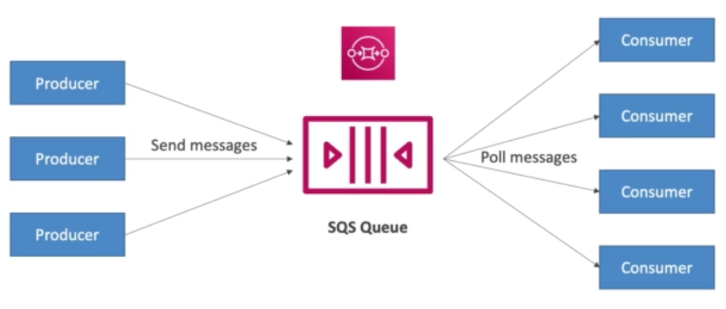

Each consumer will get a different message. And once the message is processed, the message is deleted.

* Oldest offering
* Serverless, fully managed
* Default retention is **4 days (max: 14 days)**
* Low latency
* No limit on how many msgs can be in queue

**SNS (**Simple notification service**):**

* One msg to many receivers: SNS Topic (pub/sub)
* Event publishers -> send one msg to SNS topic
* SNS topic -> many subscribers; each topic to subscriber will get all the messages
* Subscribers can be -> HTTP/HTTPS, emails, SMS msgs, mobile notifications, SQS queue

**Kinesis:**

* Real time big data streaming
* **Managed service**: collect, process, analyze real time streaming data @ any scale

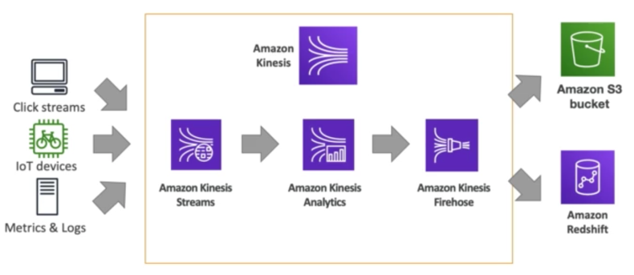

**Amazon MQ:**

* SQS, SNS -> cloud native services -> proprietary protocols from aws
* If a company is running traditional applications that use open protocols like MQTT, AMQP, STOMP etc and wants to migrate to cloud then they’ll have to change their application to use SNS/SQS. In this case they can use Amazon MQ = managed Apache ActiveMQ
* Amazon MQ doesn’t scale as much as SNS/SQS
* Runs on a dedicated machine (**not serverless**)
* Has both SNS and SQS features

**SECTION 11: CLOUD MONITORING**

**CloudWatch Metrics and Alarms:**

* CloudWatch provides **metrics** for every service is AWS
* Metrics -> timestamps
* CloudWatch dashboard -> to visualize all metrics
* *Billing*: CloudWatch billing metric (us-east-1),

*EC2*: CPU utilization, status checks, network (default every 5 mins, option for detailed monitoring -> every 1 minute)

*EBS volumes*: Disk read/writes

*S3 buckets*: bucket size bytes, number of objects, all requests

*Service limits*: how much you’ve been using a service API

*Custom metrics*: push your own metrics

* **CloudWatch Alarm**: used to trigger notifications for any metrics
* Alarm actions: Auto scaling, EC2 actions (stop, terminate, rreboot), SNS notifications
* Various options (sampling, min, max, %%)
* Can choose period on which to evaluate an alarm
* Ex: create a billing alarm on billing metric (us-east-1)
* Alarm states: OK, INSUFFICIENT_DATA, ALARM

**CloudWatch Logs:**

* Collects log files
* You can collect logs from elastic beanstalk, ECS, AWS Lambda, CloudTrail, Route 53
* Enables real-time monitoring of logs
* Adjustable CloudWatch retention

CloudWatch logs for EC2:

By default no logs from your EC2 instance will go to CloudWatch

You need to run a **CloudWatch Agent on EC2 to push the log files** you want

Make sure IAM permissions are correct

CloudWatch log agent can be set up on **on-premises too**

**CloudWatch Events/EventBridge:**

A way for you to react to events happening on AWS

* Schedule: Cron jobs

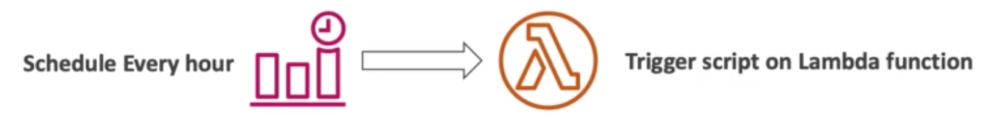

* Event pattern: event rules to react to a service doing something



EventBridge:

* **Next evolution of CloudWatch events**
* Default event bus: generated by AWS services
* Partner event bus, Custom event bus
* Schema registry: model event schema

**CloudTrail:**

* Provides **governance, compliance and audit** for your AWS acc
* Enabled by default
* Get a history of events/API calls made within your AWS acc (You can transfer these logs from CloudTrail -> CloudWatch or S3 if u want trails for more than **90 days**)
* Trail can be applied to ALL regions (default) or a single Region
* If a resource is deleted in AWS, investigate CloudTrail
* *CloudTrail events:*
* Management events: operations that are performed on your resources in AWS

Read events and Write events

* Data events: by default not logged. S3 object level activity. Read events and Write events. AWS lambda fnc execution activity
* CloudTrail Insights Events: detect unusual activity, continuously analyze write events to detect unusual patterns
* CloudTrail event retention: events stored for 90 days. For longer retention -> s3 -> Athena (to analyze)

**AWS X-Ray Overview:**

* Debugging in production, the good old way: test locally -> Add log statements -> re deploy in production
* Log formats differ across applications and log analysis is hard
* Debugging one big monolith -> easy, distributed -> hard
* No common views on your entire architecture
* Enter AWS X-Ray -> **visual analysis** of your application
* Benefits: troubleshooting performance, pinpoint service issue, review request behavior, find errors and exceptions, understanding dependencies in a microservice architecture, meeting w SLA (service level agreement), identify users impacted

**Service health Dashboard:**

* Shows all regions, all services health
* Shows historical info for each day
* RSS feed you can subscribe to, to get notification

**Personal** **health Dashboard:**

* Alerts and remediation guidance when AWS is experiencing events that may impact you
* Personalized view of performance and availability of the AWS services underlying your resources
* Dashboard displays relevant and timely information to help you manage events in progress and provides proactive notification to help you plan for scheduled activities
* Global service. Also provides you with event log

**SECTION 12: VPC AND NETWORKING**

**VPC (Virtual private cloud):**

* Private network for you to deploy your resources in (region resource)
* VPCs have subnets – partition your network (**AZ resource**)
* Public Subnet – accessible from internet -> EC2 instances
* Private subnet – not accessible from internet -> databases (since we don’t want them to be exposed to the internet)
* To define access to internet and between subnet -> route tables

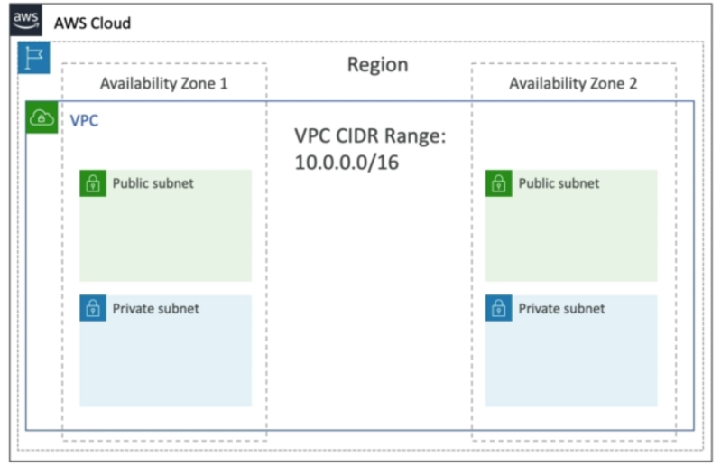

**Internet Gateway and NAT gateways:**

* Internet gateway -> helps our VPC instances connect with the internet
* Public Subnets have a route to the internet gateway (so instances in public subnets can access the internet and can be accessed by the internet)
* NAT Gateways (AWS managed) & NAT Instance (self-managed) allow your instances in your private subnet to access the internet while remaining private (so instance in private subnet can access the internet but CANNOT be accessed by the internet)

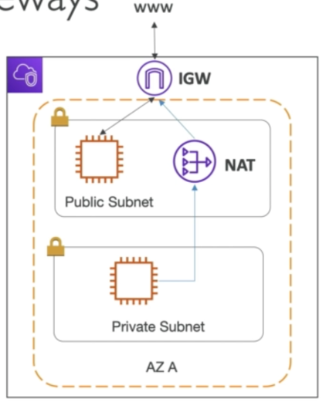

* When we create our account a default VPC is created for us

**Security Groups & Network Access Control List (NACL):**

* NACL (First line of defense for our resources in public subnet)
* A firewall which controls traffic from and to subnet
* Can have ALLOW or DENY rules
* Are **attached at subnet level**
* Rules only include IP addresses
* Security Groups (Second line of defense)
* Firewall that controls traffic to and from and ENI/EC2
* Only ALLOW rules
* Rules include **IP addresses and other security groups**

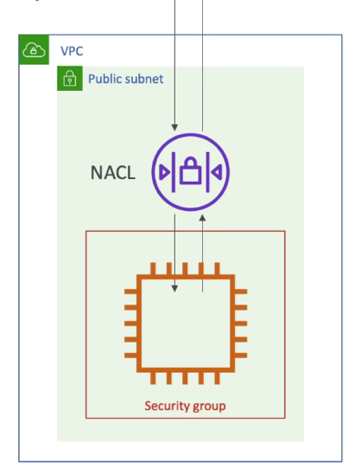

* NACL vs Security group

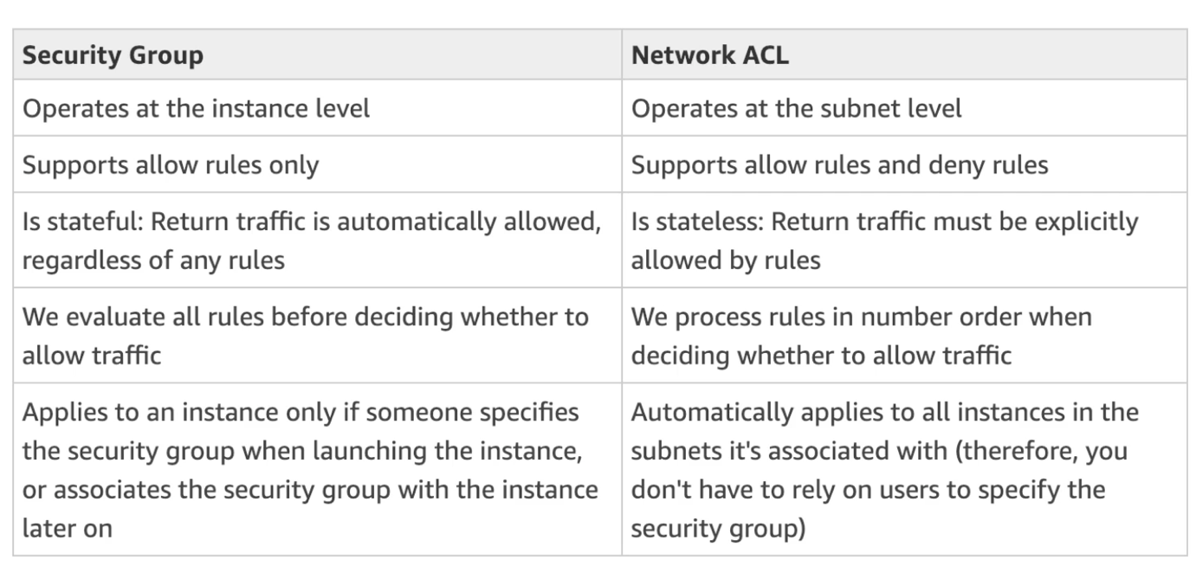

**VPC Flow Logs & VPC Peering:**

* Log of IP traffic going through your interfaces – VPC flow logs, subnet flow logs, ENI flow logs.
* Helps to monitor and **troubleshoot connectivity issues**: subnets to internet, subnet to subnet, subnet to internet
* Captures n/w info from AWS managed interfaces too: ELB, ElastiCache, RDS, Aurora
* VPC flows logs can be exported to S3 or CloudWatch
* **VPC Peering**: connect 2 VPCs using AWS’ Network. Make them behave as tho they were in the same network.

Must not have overlapping **CIDR**

VPC peering connection is not transitive (a->b&b->c != a->c)

**VPC Endpoints – Interface and Gateway (S3 and DynamoDB):**

* Endpoints allow you to connect to AWS service using a private network instead of public www network
* Gives you **enhanced security and low latency to access** AWS services
* VPC gateway: S3 and DynamoDB
* VPC Interface: rest of the services

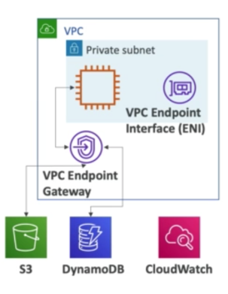

**Direct Connect & Site-to-Site VPN:**

* If you want to connect your on premise data center to your cloud (VPC)
* Option 1: site to site VPN – Connects **on premise VPN to AWS**. Connection is automatically **encrypted.** Goes over **public internet.**

On premise: must use a **customer gateway**; AWS side: **Virtual private gateway**.

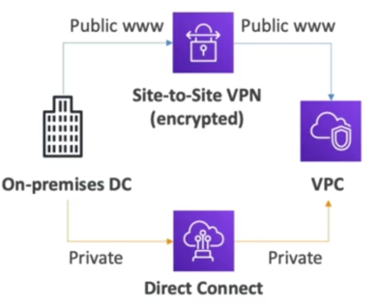

* Option 2: Direct connect (DX) – establish an actual physical connection. Network -> private secure and fast. More expensive.

**Transit gateway:**

* For transitive Peering connection between thousands of VPCs & on-premise, through hub-and-spoke (star) connection.

**SECTION 13: SECURITY AND COMPLIANCE**

**AWS Shared Responsibility Model:**

* AWS – security of the cloud (protecting the infrastructure); managed services
* Customer – security in the cloud (OS in EC2, firewall, IAM, encryption of application data)
* Shared controls – patch management, configuration management, Awareness training

Example RDS:

* AWS – Manage underlying EC2 instance, **disable SSH access**, Automated DB and OS patching, audit the underlying instance and disks and guarantee it functions
* Customer – check ports/IP/security group inbound rules in DB’s SG, in database use creation and permissions, creating a db with or w/o public access, db encryption

Example S3:

* AWS – guarantee you get unlimited storage or you get encryption whenever u want it, ensure separation of data b/w customers, ensure AWS employees can’t access your data
* Customer – bucket config, bucket policy, IAM user/roles

**DDoS Protection (WAF and Shield):**

* Distributed Denial of Service attack
* AWS Shield standard: protects against DDoS attach for your website and application, for all customer w no extra cost
* AWS Shield Advanced: 24/7 premium DDoS protection
* **AWS WAF**: Filter specific requests based on rules
* CloudFront and Route 53: Availability protection using global edge network, combined w AWS Shield, provides attach mitigation at edge loc.
* Be ready to scale – leverage AWS auto scaling

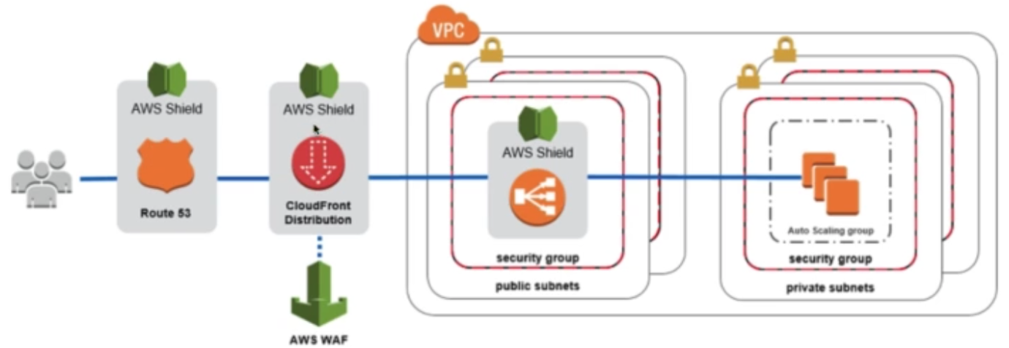

AWS Shield:

* Free service
* Provides protection against SYN/UDP floods, reflection attacks and other 3/layer 4 attacks

AWS Shield Advanced:

* Optional paid service
* Protection against more sophisticated attack
* Access to response team
* Protect against higher fees during usage spikes due to DDoS

WAF (Web Application Firewall):

* Protects your web application from common web exploits (layer 7)
* Deploy on Application LB, API gateway, CloudFront
* Define **Web ACL**:
* Filter IP addresses
* Protection against common attacks
* Size constraints, geo-match (block countries)
* Rate based rules (to count occurrences of events) – for DDoS protection

**Penetration testing:**

* Trying to attack your own architecture for testing.
* No need for approval for 8 services
* Prohibited activities: DoS, DDoS, Port flooding, protocol flooding, request flooding, DNS zone walking

**Encryption with KMS and CloudHSM:**

* 2 types of encryption: encryption at rest (when data in EFS, RDS, S3 glacier etc.) or in transit (transferring data from on premise to AWS, EC2 to dynamo etc.)
* We want to encrypt data in both states -> using encryption keys
* **AWS KMS (key management service): We don’t have access to keys, AWS manages for us, we just define who can access the keys.**
* Automatic encryptions: **CloudTrail, storage gateway, S3 glacier**
* CloudHSM: AWS provisions encryption Hardware (unlike KMS where AWS manages the software for encryption); Dedicated HSM module provided, key management done by customer, tamper resistant

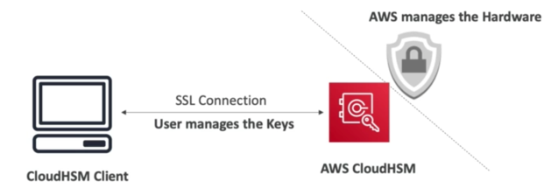

Types of Customer Master keys: CMK

* Customer managed CMK – create, manage and used by customer; can enable/disable them; possibility of rotation policy (new key generated every year, old key preserved)
* AWS managed CMK: Created, managed and used on customers behalf by AWS; used by AWS services
* AWS owned CMK: collection of CMKs that an AWS service owns and manages to use in multiple accounts
* CloudHSM keys (custom keystore): Keys generated from your own cloudHSM device

**Secrets Manager:**

* Newer service, meant for storing secrets
* Force rotation of secrets (change password every 90 days)
* Automate generation of secrets on rotation (uses Lambda)
* Integration with RDS (MySQL, PostgeSQL, Aurora) – create passw for RDS automatically
* Secrets are encrypted using KMS
* Mostly meant for RDS integration
* Paid service

**Artifact Overview:**

* (not really a service - global) Portal that provides customers with on-demand access to AWS compliance doc and AWS agreements.
* **Artifact reports**: Allows you to download AWS security and compliance docs from third party auditors
* **Artifact Agreements**: allows you to review, accept, and track the status of AWS agreements

**GuardDuty:**

* Intelligent threat discovery system
* Uses ML, anomaly detection, 3rd party data
* One click enable, 300 days trial, no need to install s/w
* I/P data includes: **CloudTrail logs, VPC flow logs, DNS logs**
* Can set up CloudWatch events rules to be notifies in case of findings
* CloudWatch events rules can target SNS or Lambda

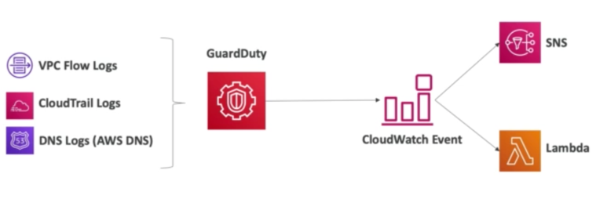

**Amazon Inspector:**

* Automated security assessments for EC2 instances
* Analyze running OS for known vulnerabilities
* Analyze against unintended n/w accessibility
* To be **installed on OS in EC2 instance**
* After assessment, you get a report with a list of vulnerabilities

**Config Overview:**

* Helps with auditing and recording compliance of your AWS resources
* Helps record configurations and changes over time -> data stored in s3, analyzed by Athena
* You can receive alerts for any changes
* **Per-region service, paid**
* Can be integrated across region, and accounts

**Macie:**

* Fully managed data security and data privacy service that uses ML and pattern matching to discover and protect sensitive data in AWS
* Macie helps identify and alert you to sensitive data as personally identifiable information (PII)
* One click enable

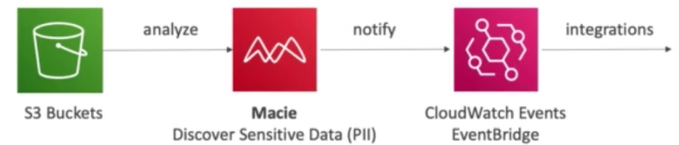

**Security hub:**

* Central security tool to **manage security across several AWS accounts** and automate security checks
* Integrated dashboard showing current security and compliance status to quickly take actions
* Automatically aggregates alerts in predefined or personal findings formats from various AWS services and AWS partner tools: GuardDuty, Inspector, Macie, IAM Access analyzer, Systems manager, Firewall manager etc.
* All alerts in one place -> security hub <- enable config service

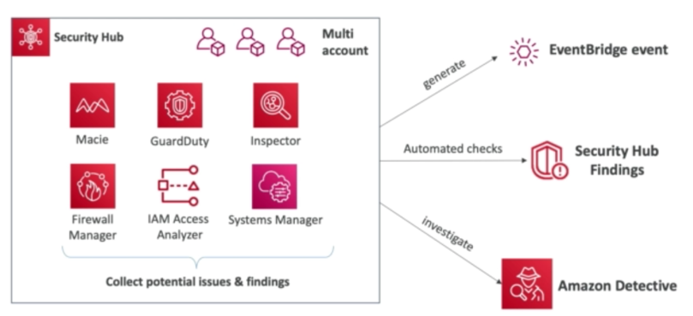

**Amazon Detective:**

* GuardDuty, Macie, security hub -> identify potential security issues
* Sometimes security findings require **deeper analysis to isolate the root cause** and take action – it’s a complex process -> detective
* Analyze, investigate, identify root cause of security issues or suspicious activity
* Collects and processes events fromVPC logs, CloudTrail, GuardDuty
* Produces visualizations

**AWS Abuse:**

* Report suspected AWS resources used for abusive or illegal purposes
* Eg: Spam, Port scanning, DDoS, Intrusion Attempt, Hosting questionable or copyrighted content, distributing malware

**Root User Privileges:**

* Account user (First user when the account is created)
* Has complete access to all AWS services and resources
* Lock away your root user access keys. Don’t use root acc for everyday activities.
* Action that only root user can do:
* Change acc settings (Acc name, email id, root user password, root user access keys)
* Close your account
* Change or cancel AWS support plan
* Register as a seller in the reserved instance marketplace
* Configure an S3 bucket to enable MFA
* Edit or delete an S3 bucket policy that includes invalid VPC ID
* Sign Up for GovCloud
* Restore IAM user permissions
* View certain tax invoices

**SECTION 14: MACHINE LEARNING**

**Rekognition:**

* Used to recognize objects, text, people, scenes in images and videos using ML
* Facial analysis and facial search to do user verification, people counting
* Create a db of familiar faces or compare against celebrities
* Use cases: labeling, content moderation, text detection, face detection

**Transcribe:**

* **Speech to text** <- uses Deep learning process called automatic speech recognition

**Polly:**

* **Text to speech**
* Allows you to create applications that talk

**Translate:**

* Natural and accurate language translation
* Helps **localize content**; translate large volumes of text efficiently

**Lex + Connect:**

* Same technology that powers Alexa
* Automatic speech recognition ; Natural language understanding to recognize intent
* Helps build chat bots and call center bots (-> Amazon Connect)
* Amazon connect: Receive calls, create contact flows, cloud-based virtual contact center, Integrate with other CRM, No upfront payments, 00% cheaper than traditional contact center solutions

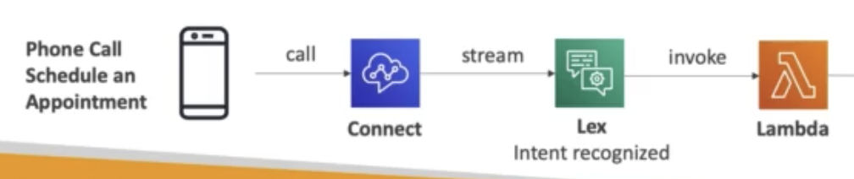

**Comprehend:**

* NLP
* Fully managed and serverless service
* Use **ML to find insights and relationships in text**
* Language of text
* Extract key phrases, places, people etc.
* Understands how +ve or -ve text is
* Analyzes text using tokenization
* Automatically organizes a collection of text files by topic
* Use cases: Analyze customer interactions; create and group articles by topic

**Sagemaker**:

* Fully manager service for developers and data scientists to **build** ML models
* Typically difficult to do all processes in one place + provision servers -> Sagemaker

**SECTION 15: ACCOUNT MANAGEMENT, BILLING & SUPPORT**

**Organizations:**

* Global service
* Allows you to manage multiple AWS accounts, Main acc -> master acc
* Benefits:
* Consolidated billing across all accs
* Pricing benefits from aggregated usage
* Pooling of reserved EC2 instances
* API available to **automate AWS acc creation**
* Restrict acc privileges using **Service Control Policy (SCP)**

Multi account strategies:

* Create acc per dept, per cost center, per dev/test/prod, based on rergulatory restrictions (using SCP), for better resource isolation (ex:VPC), to have separate per-account service limits, isolated acc for logging
* Two options: multi acc VS one Acc multi VPC
* Use tagging stds for billing purposes
* Enable CloudTrail -> send logs to central S3 acc
* Send CloudWatch logs to central logging acc

Organizational Units (OU):

Business Unit: Sales OU, Business OU

Environment Lifecycle: dev, test, prod

Project based: project 1, 2, 3

Service Control Policy:

* Whitelist or blacklist IAM actions @OU or account level
* **Doesn’t apply to Master** account
* SCP applied to all User and Roles of the acc, including root
* The SCP doesn’t effect service linked roles (service linked roles enable other AWS services to integrate with AWS organizations and can’t be restricted by SCPs)
* Must have explicit ALLOW (by default its DENY)
* Use cases:
* Restrict access to certain services
* Enforce PCI compliance by explicitly disabling service

SCP Hierarchy:

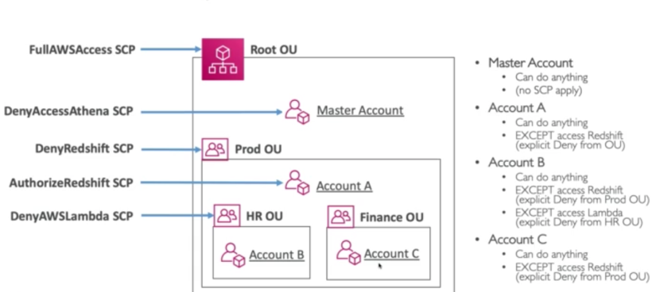

**AWS Control Tower Overview:**

* Easy way to **set up and govern a secure and compliant multi-account AWS environment** based on best practices
* Benefits:
* Automate set up of your env with a few clicks
* Automate ongoing policy management using **guardrails**
* Detect policy violations and remediate them
* Monitor compliance through an interactive dashboard
* Runs on top of **AWS Organization ->** automatically sets up AWS organizations to organize accounts and implement SCPs

**Pricing Models of the Cloud:**

* 4 different pricing models

1. Pay as you go
2. Save when you reserve
3. Pay less by using more (volume based discounts)
4. Pay less as AWS grows

* *Free services and free tier in AWS*: IAM, VPC, Consolidated billing, {Elastic Beanstalk, CloudFormation, ASG – you pay for the resources created}
* Different types of free tier
* Compute Pricing – EC2:
* Only charged for what you use
* Number of instances
* Instance configuration (Phy capacity, type, size etc.)
* ELB running time and amt of data processed
* Detailed monitoring
* Models of pricing – EC2
* On demand instances: minimum of 600s
* Reserved instances (up to 75% discount – 11 or 3 yr – upfront or partial upfront)
* Spot instances
* Dedicated host
* Savings plan
* Models of pricing – Lambda & ECS
* Lambda: pay per call, duration
* ECS: no fees for ECS but you pay for the EC2 instances
* Fargate: Pay for vCPU and memory resources allocated to your applications in your container
* Models of pricing – S3
* Number and size of objects: prices can be tiered based on volume
* Number and type of requests
* Data transfer OUT of S3
* S3 data transfer acceleration
* Lifecycle transitions
* EFS: pay per use (has infrequent access and Lifecycle rules)
* Models of pricing – EBS
* Volume type (based on performance)
* Storage volume in GB per month provisioned
* IOPS
* Snapshots
* Outbound data transfer
* Models of pricing – RDS
* Per hour billing
* Database char: engine, size, memory class
* Purchase Type: On demand, reserved
* Backup storage
* Additional storage (EBS)
* No of I/P and O/P requests
* Deployment type: single AZ, multiple AZ
* Data transfer: Outbound data
* Models of pricing – CloudFront
* Pricing is different across diff geographic regions
* The more you use CloudFront in an edge location, the more discounts
* Aggregated bill for all edge location
* Data transfer out
* Number of HTTP/HTTPS requests
* Networking Costs:

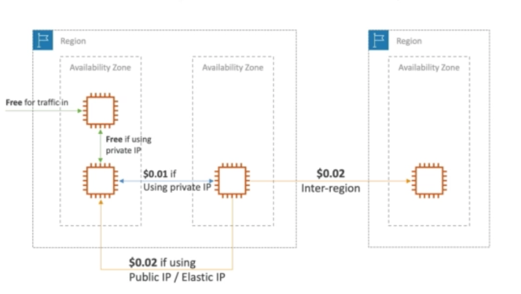

Use private IP > public IP for cost savings and better n/w performance

Use same AZ for max cost savings

**Savings Plan:**

* Commit a certain $ amount per hour for 1 or 3 years
* Easiest way to set up long-term commitments on AWS
* EC2 savings plan:
* Up to 72% discount
* Commit to usage of individual instance families in a region (eg C5 or M5)
* Regardless of AZ, size, OS or tenancy
* Upfront, partial upfront, no upfront
* Compute Savings plan:
* Up to 66% saving
* Regardless of family, region, size, OS or tenancy
* Compute options: EC2, fargate, lambda
* Set up from AWS cost explorer console

**Billing & Console Tools Overview:**

* Estimating Costs in Cloud:
* TCO Calculator (deprecated)
* Simple monthly calculator (deprecated ) ->Pricing Calculator
* Tracking costs in Clous:
* Billing dashboard
* Cost Allocation Tags
* Cost and usage reports
* Cost explorer
* Monitoring against cost plans
* Billing alarms
* Budgets

**Estimating Costs in Cloud - TCO Calculator & Pricing Calculator:**

* **TCO** – total cost of ownership
* Helps you reduce TCO by reducing the need to invest in large capital expenditures and providing a pay-as-you-go model
* Allows you to estimate the cost savings when using AWS and provide a detailed set of reports
* Compare the cost of your application on premise to on AWS (server, storage, n/w,IT labor costs)
* **Pricing calculator –** estimate cost for your architecture solution

**Tracking costs in Cloud - Billing dashboard, Cost Allocation Tags, Cost and usage reports,**

**Cost explorer**

* Billing dashboard: will show all costs incurred in the month, forecast and the month to date
* AWS free tier dashboard: shows usage so far
* Cost allocation tags: allow you to track your AWS cost in detail and groups them together. AWS generated tags and user defined tag.
* Tags and resource groups: Tags are used for organizing resources (EC2, RDS, VPC)
* Edit using tag editor
* Cost and usage report: dive deeper into your AWS costs and usage
* The AWS Cost and usage report contains the most comprehensive set of AWS cost and usage data available, including additional metadata about AWS services, pricing and reservation
* It lists AWS usage for each service by account and its IAM users in hourly or daily line items, as well as any tags activated for Cost allocation purposes.
* Can be integrated with Athena, redshift, QuickSight
* Cost Explorer: visualize, understand and manage your AWS costs and usage over time
* Create custom reports that analyze cost and usage data
* Analyze your data at a high level: total cost, usage across all acc
* Monthly, hourly, resource level granularity
* Choose an optimal savings plan
* Forecast usage up to 12 months based on previous usage

**Monitoring against cost plans - Billing alarms, Budgets:**

* Billing metric -> CloudWatch us-east-1
* Billing data are for overall worldwide AWS costs
* Actual cost not projected
* Billing alarm on top of billing metric – email, sms notification
* **Budgets**: send alarms when cost or forecast exceed budget
* 4 types: usage, cost, reservation, saving plan
* For reserved instances: Task utilization, supports EC2, ElastiCache, RDS, Redshift
* 5 SNS notifications budget
* Can filter by: service, linked acc, tag, purchase option, instance type, region, AZ
* Same options as AWS cost explorer
* First 2 budgets are free

**AWS Trusted Advisor:**

* No need to install anything – high level AWS acc assessment
* Analyze your AWS acc and provide recommendation:

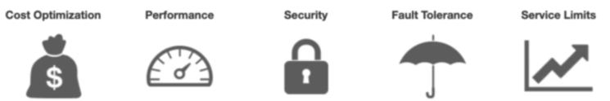

* Core checks and recos – all customers – Can enable weekly email
* Fully trusted advisor: business and enterprise support plan
* Ability to set up cloudwatch alarms when reaching limits
* Programmatic access

Use cases:

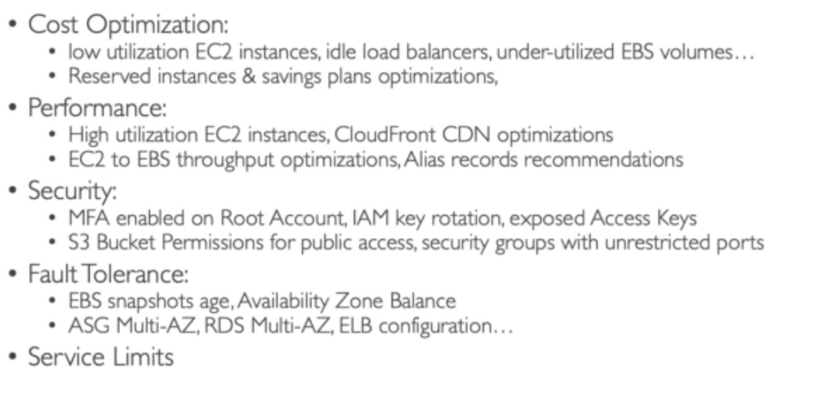

**Support plans for AWS:**

* **Basic support: *free*** – 24x7 customer service & communities, 7 core trusted advisor checks, AWS personal health dashboard
* ***Developer*** – all basic support + business hours email access to cloud support associates
* Unlimited cases/ 1 primary contact
* Case severity – response time (general guidance, system impaired)
* ***Business***– full sets of check for trusted advisor + API access
* 24x7phone, email, and chat access to cloud support engineers
* Unlimited cases/ 1 Unlimited contact
* Access to infrastructure event management for additional fee
* Case severity – response time (general guidance, system impaired, prod system impaired
* ***Enterprise*** *–* Huge enterprise
* ***Access to dedicated technical manager***
* ***Concierge support group (for billing best practices)***
* infrastructure event management, well architected & operations review
* Case severity – response time (general guidance, system impaired, prod system impaired, business critical system down)

